Modere Web Page- Placing Orders

One Time Order
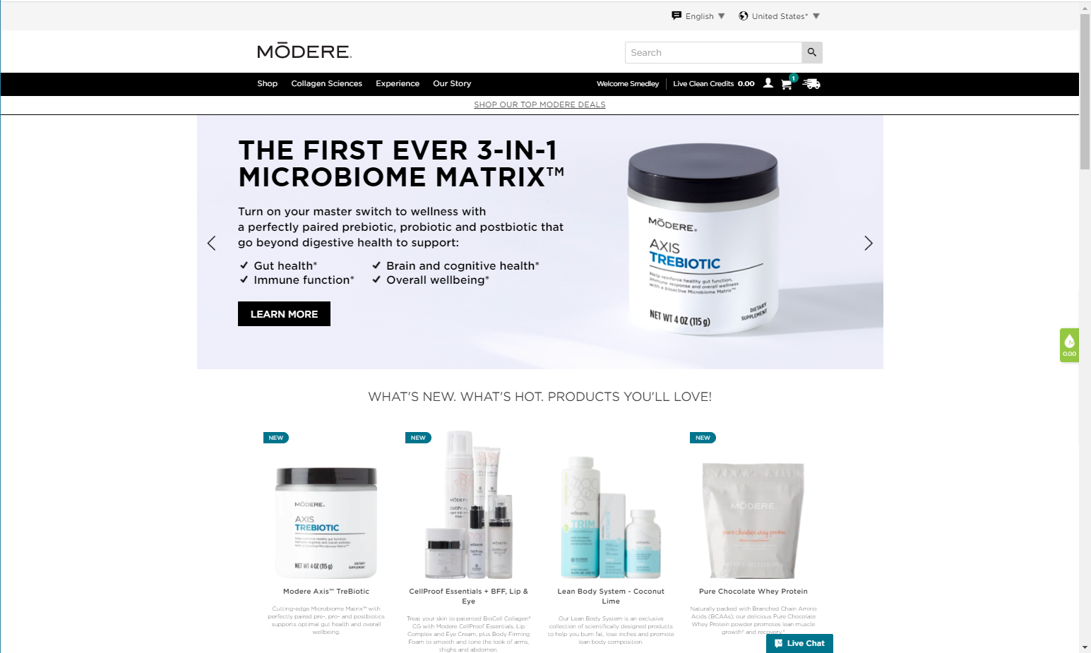
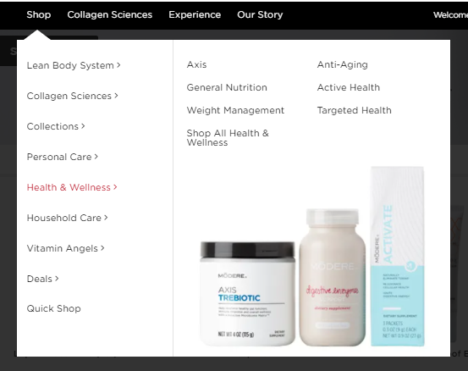
After logging in, select products for the shopping cart. Scrolling down the page exposes the trending products. Selecting a menu item, such as Shop, exposes the categories under that menu item. This customer has one item in the cart.
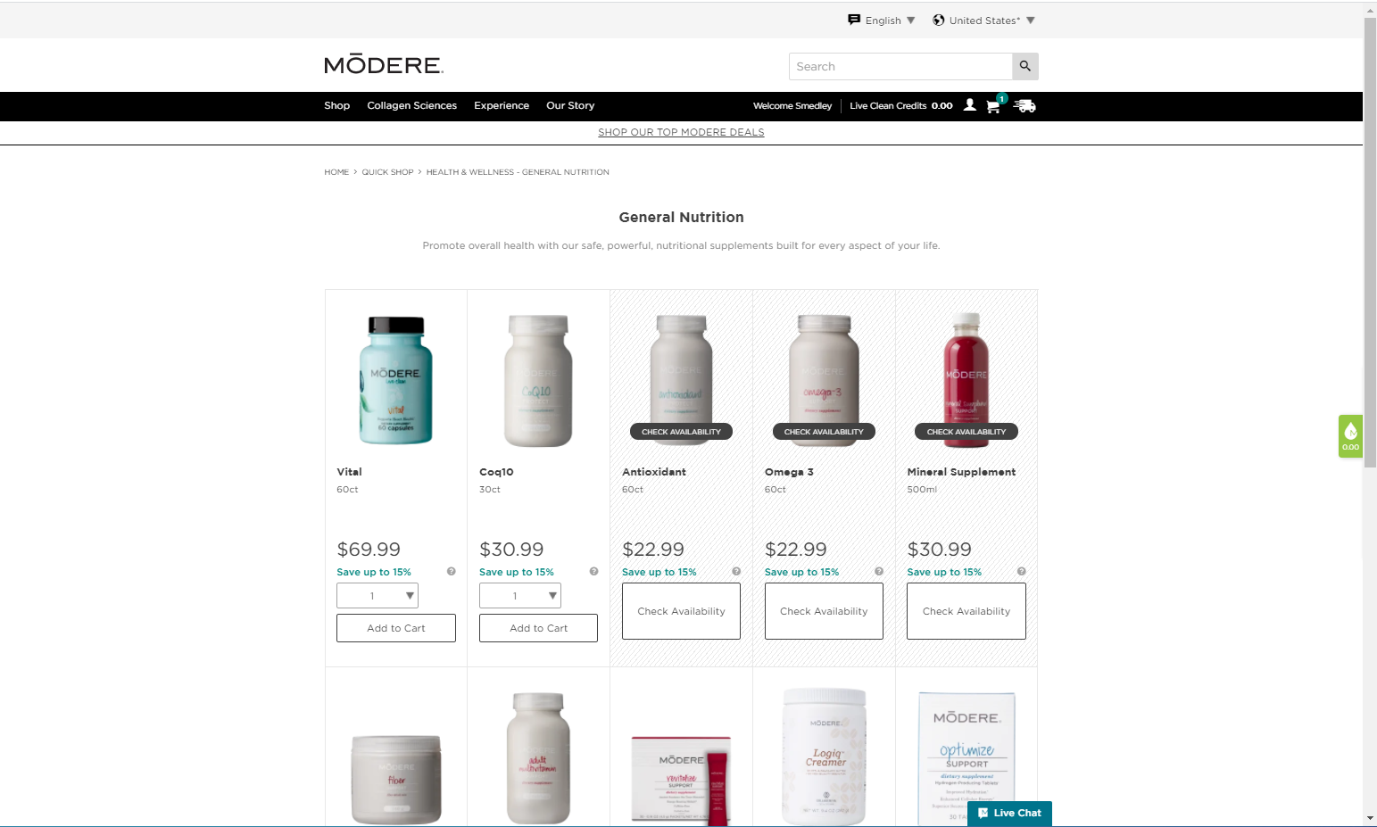Selecting Shop -> General Nutrition opens the General Nutrition products page. To add a product to the cart, click the Add to Cart button. Click the quantity dropdown to increase the quantity of the item.

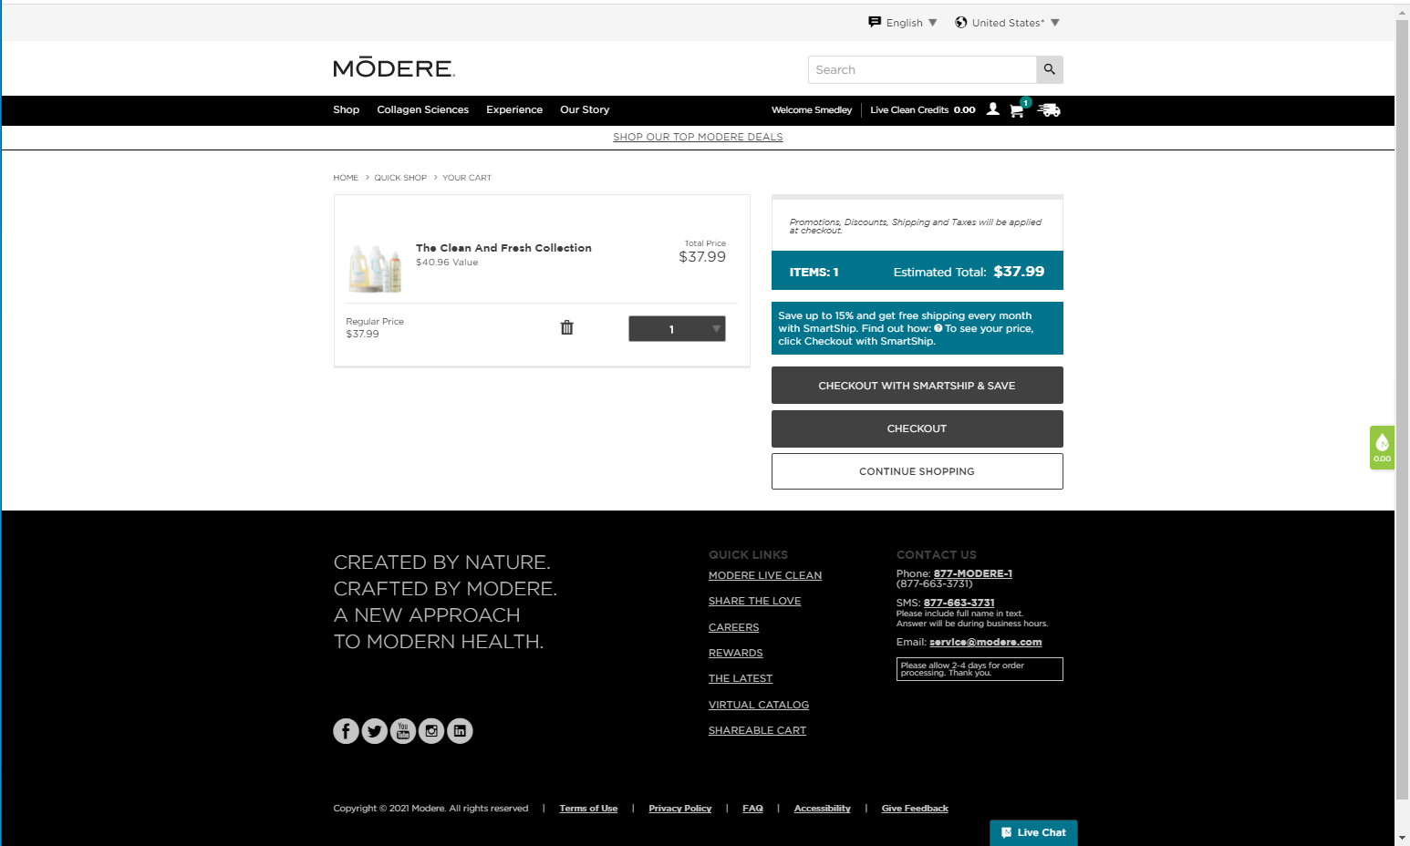
Clicking the cart icon opens the cart. Note that there is a statement indicating that any discounts will be applied upon checkout. Since the cart’s contents are only available to the customer, Modere customer support agents cannot see the cart in their system.
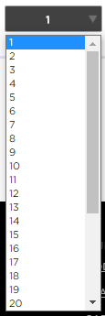
The Cart displays the items currently in the cart. Click the quantity drop down to change how many of each item in the cart is being ordered.
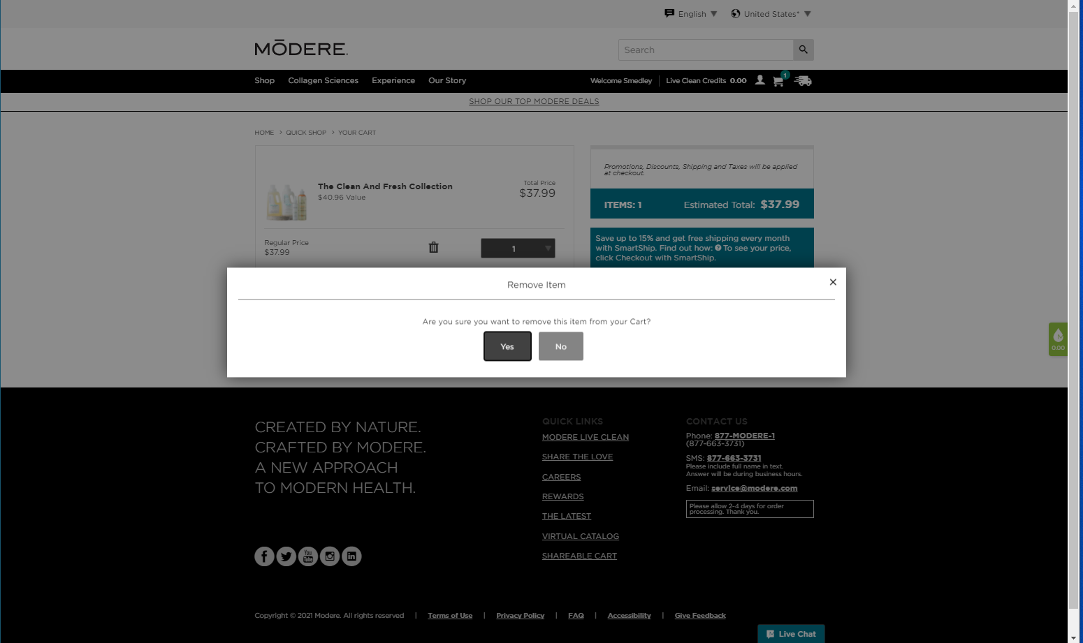
Delete the item by clicking the Trash Can icon, then confirm the delete by clicking the Yes button.
Click the Checkout button to proceed with the one-time order.
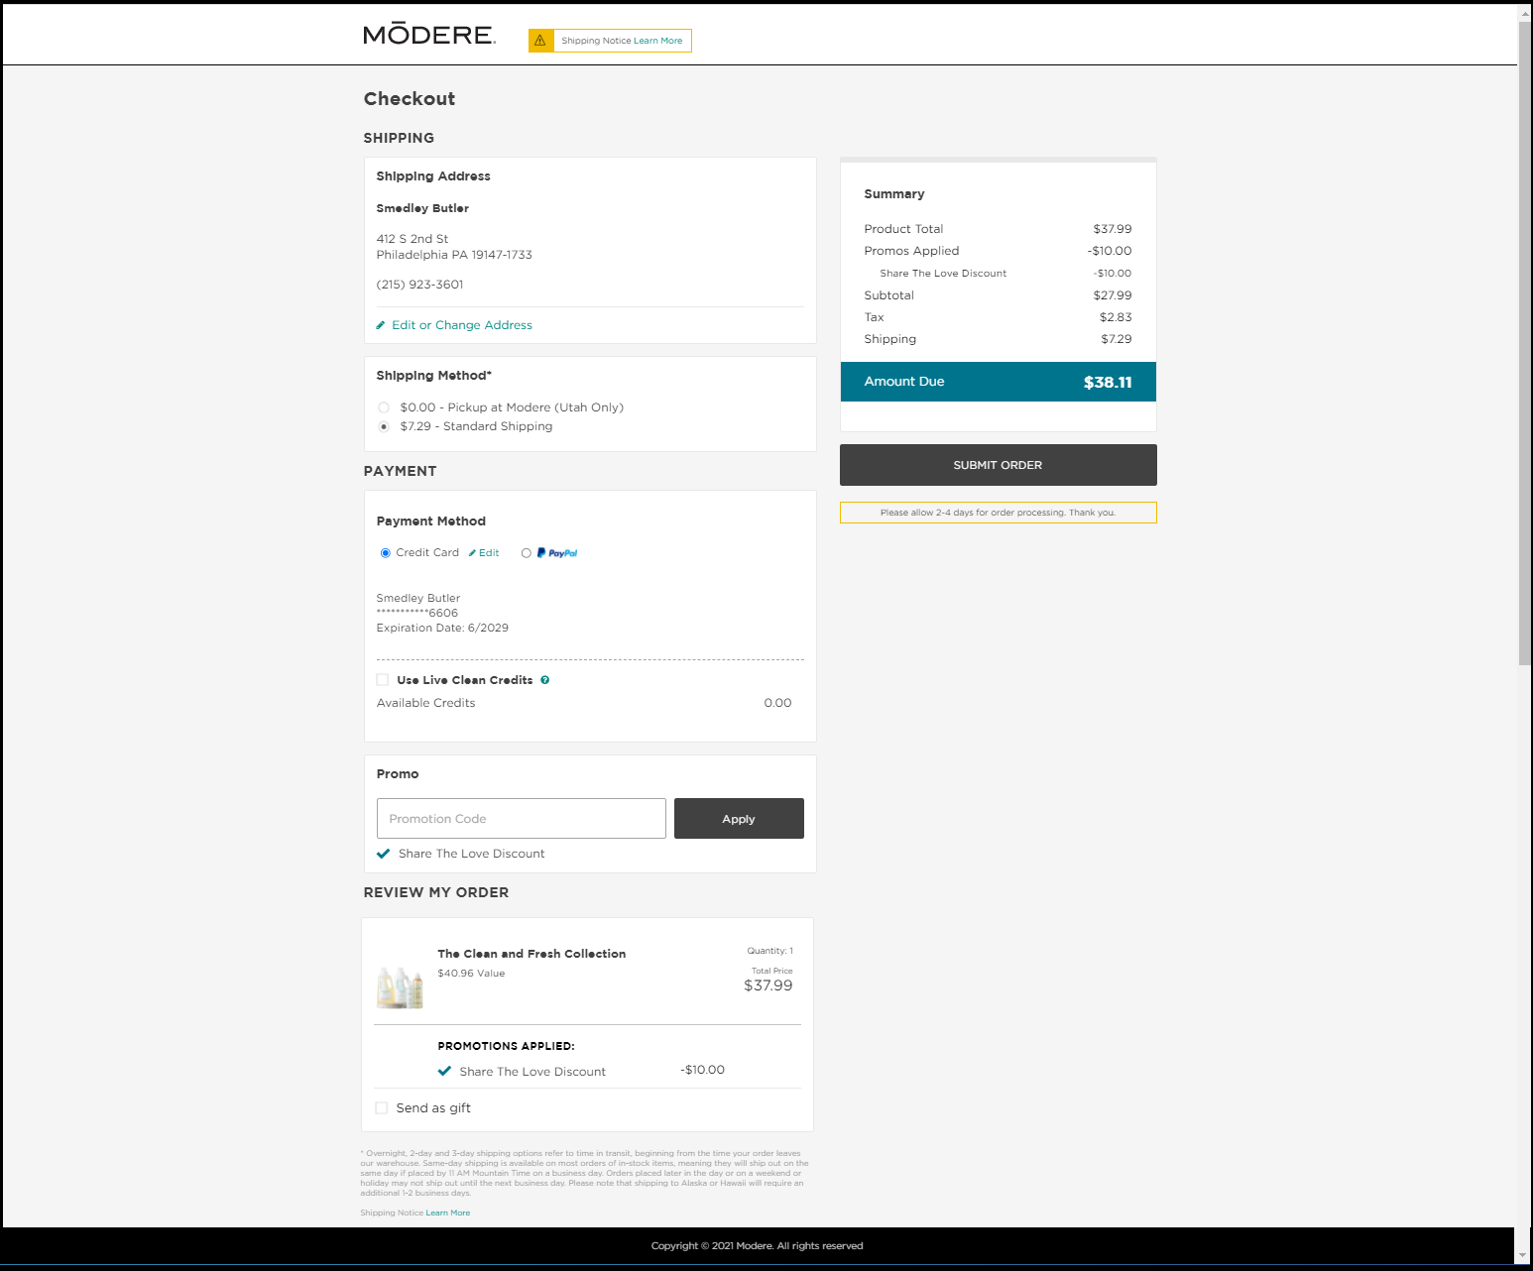
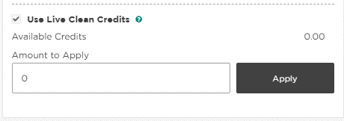
Click the Use Live Clean Credits checkbox to apply any available credits of 50 or more. Click the Submit Order button to submit the order and charge the credit card.
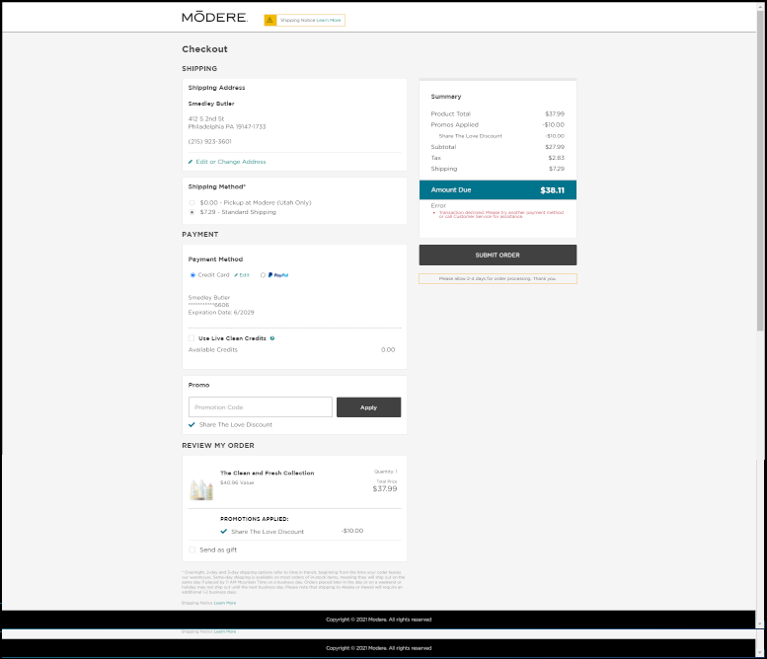
If the credit card has an issue the system will return an error message. The most common reason for a card issue is a billing address and account address mismatch. In these cases, you must call customer support for assistance.
When the order is complete it will be visible to the Modere customer support agents.
SmartShip Setup
When you want to turn the cart contents into a SmartShip, click on the Checkout With SmartShip & Save button.

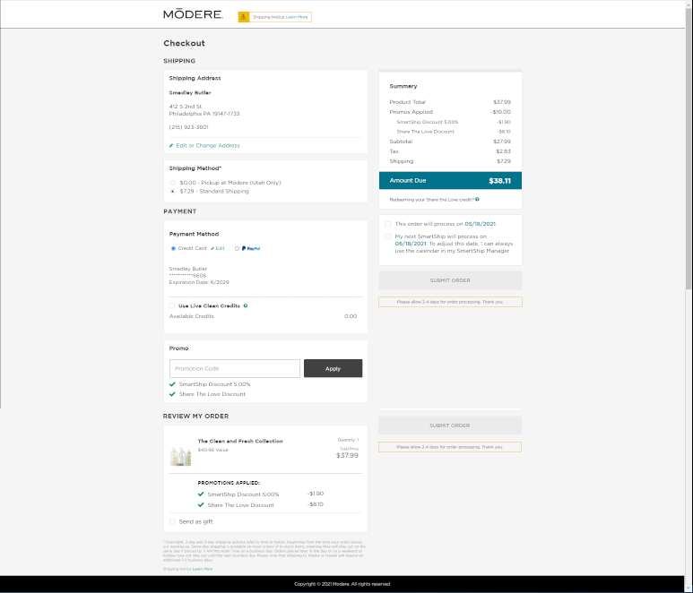
The SmartShip check out is very similar to the one-time order checkout. Because it is a SmartShip the SmartShip discount is applied. The SmartShip discount on this item is $1.90. Since we offer a minimum of $10 discount for the customer’s first order, the Share The Love Discount is applied for an additional $8.10.
The Submit Order button is not available until you check the two checkboxes acknowledging that the order will process the day it is placed and that it will process again in 30 days.
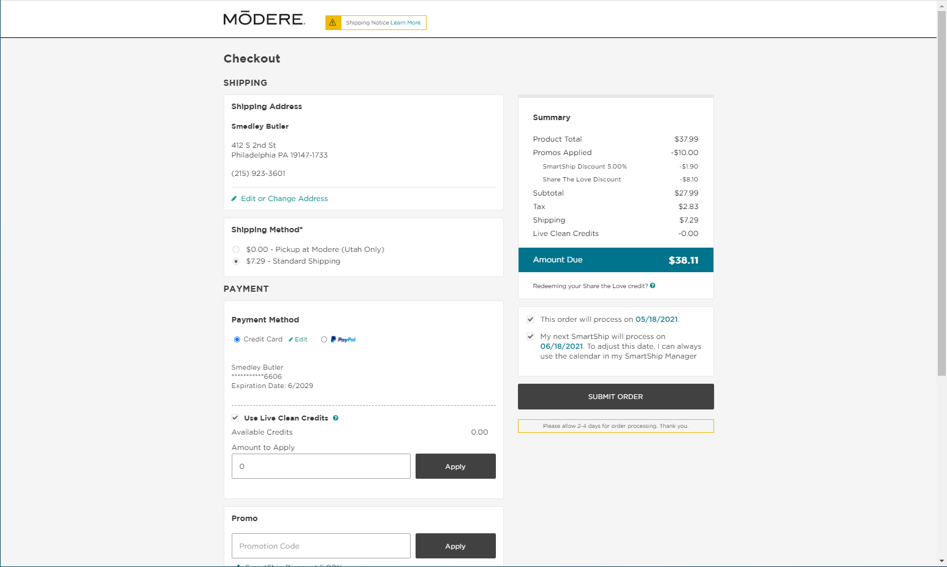
Click the Submit Order button to create the immediate order and create a SmartShip template in the account scheduled for 30 days later.
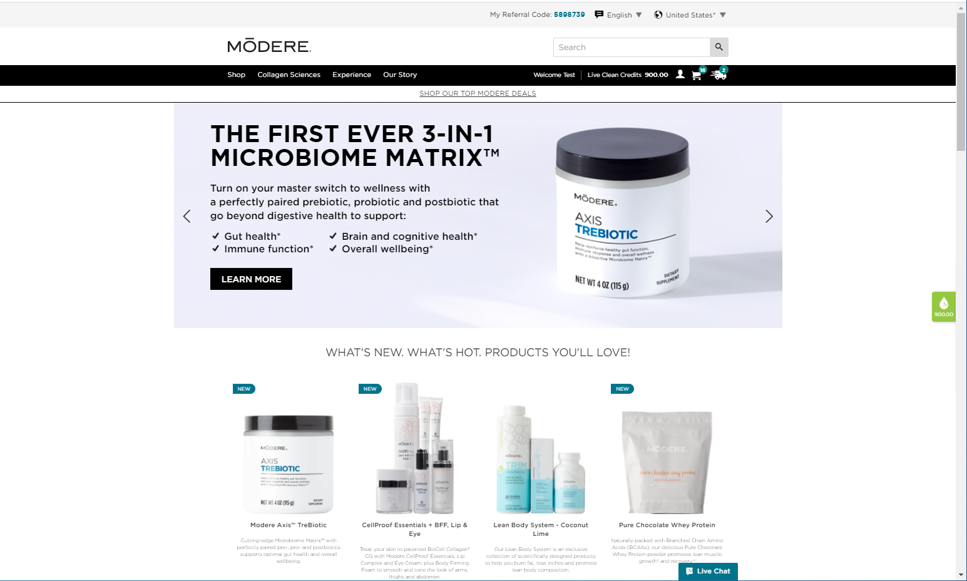
The SmartShip icon shows a circle with a number to indicate a SmartShip exists and how many items it contains. Click the SmartShip icon to open the SmartShip Manager.
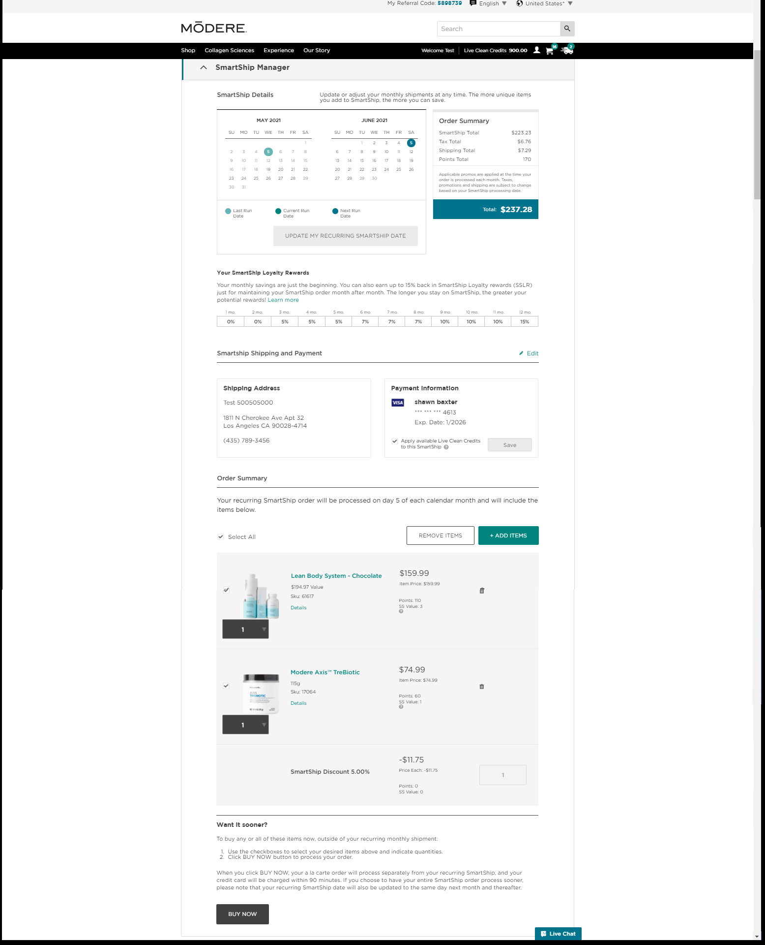
The SmartShip Manager gives you control over your SmartShip.
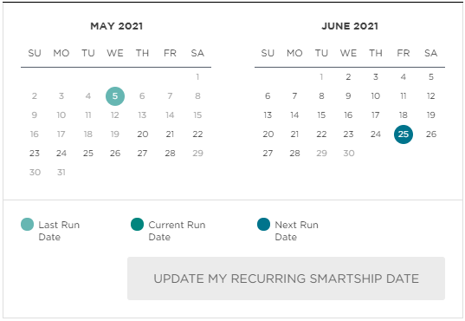
This customer’s SmartShip ran last on May 5th and is scheduled to run next on June 25th. Change the SmartShip date by clicking on a date in the future. Note that the 1st and the 29th to the end of the month are not available. This is to facilitate commissions calculations at the end of the month.
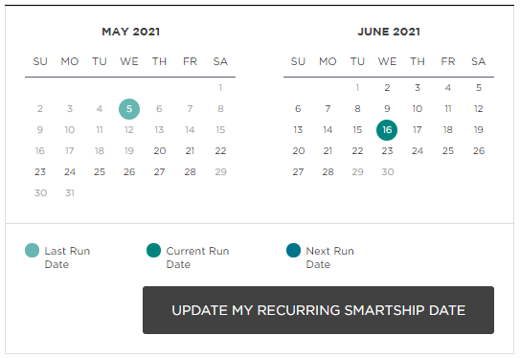
When a new date is selected, the Update My Recurring SmartShip Date button becomes available.
After saving the new date the system will send a confirmation message that the SmartShip has been updated.
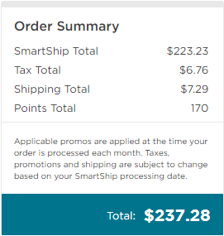
The Order Summary panel shows the total cost of the shipment and a reminder them that any discounts and promotions are applied when the order is processed.
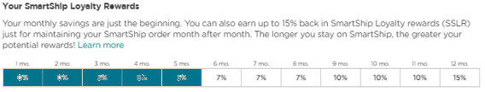

The SmartShip Loyalty status is displayed as a bar that becomes colored in as the number of continuous months grows. The Learn More link opens the https://www.modere.com/smartship page.
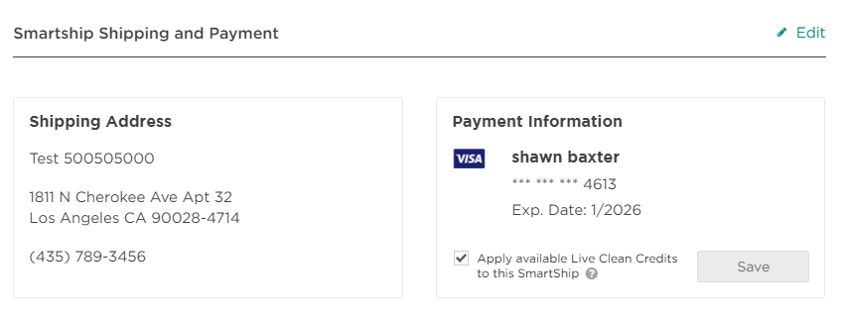
Update your shipping address by clicking the Edit link.
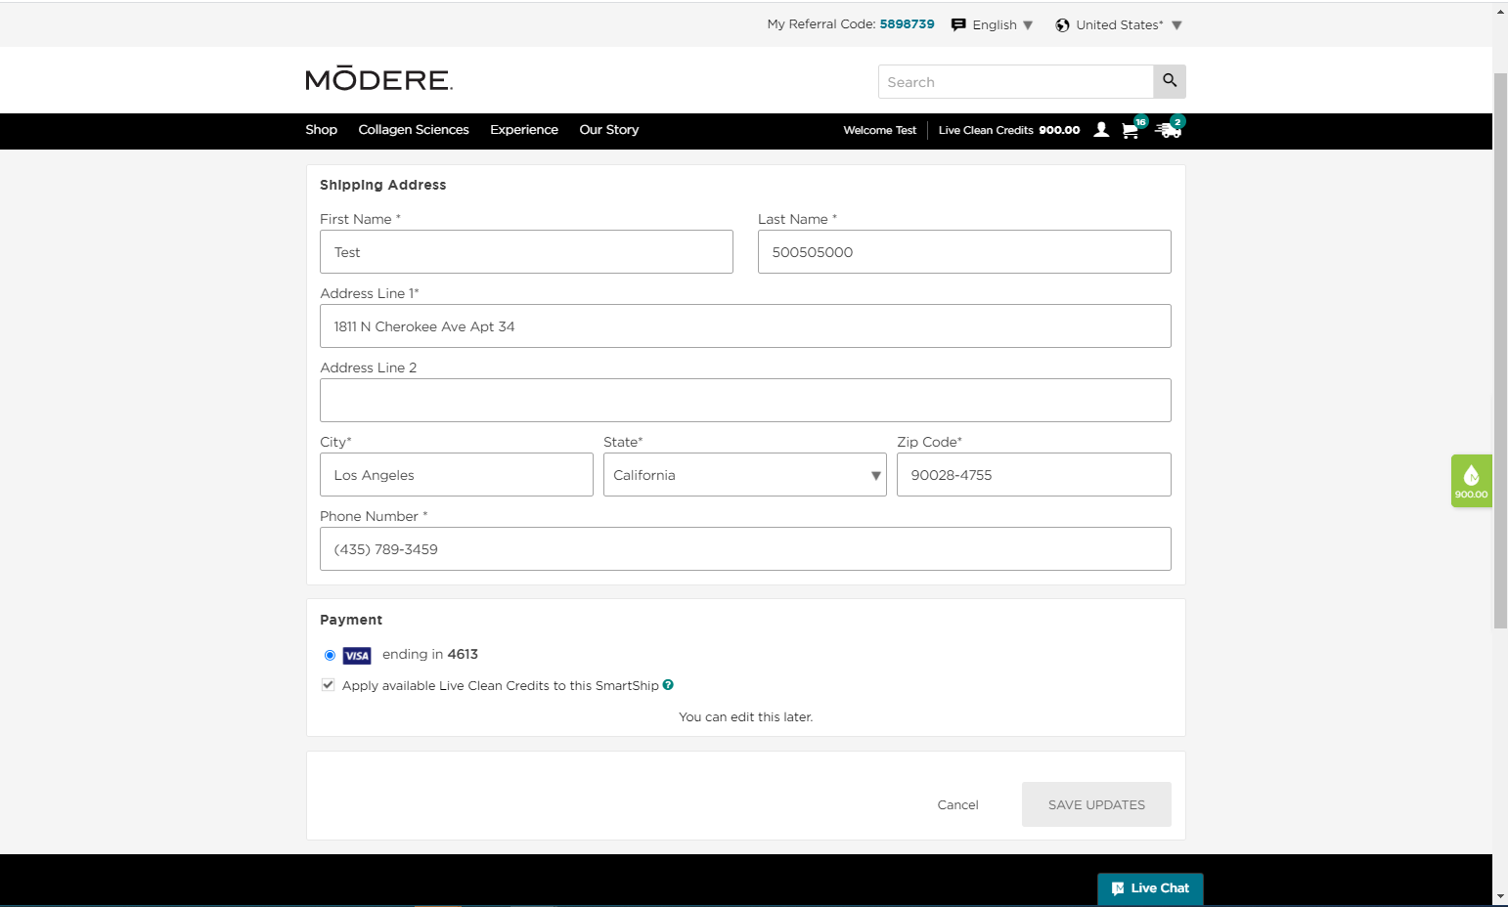
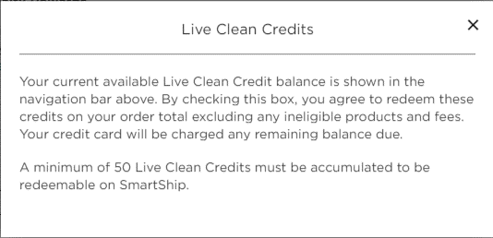
Make any necessary edits. When the data has been edited the Save Updates button becomes active.
Checking/Unchecking the Apply available Live Clean Credits checkbox enables/disables Live Clean Credit application to an order. Clicking on the question mark displays an explanation of the Live Clean Credit program, to include the 50-credit limit.
Edit the credit card information in the user profile.
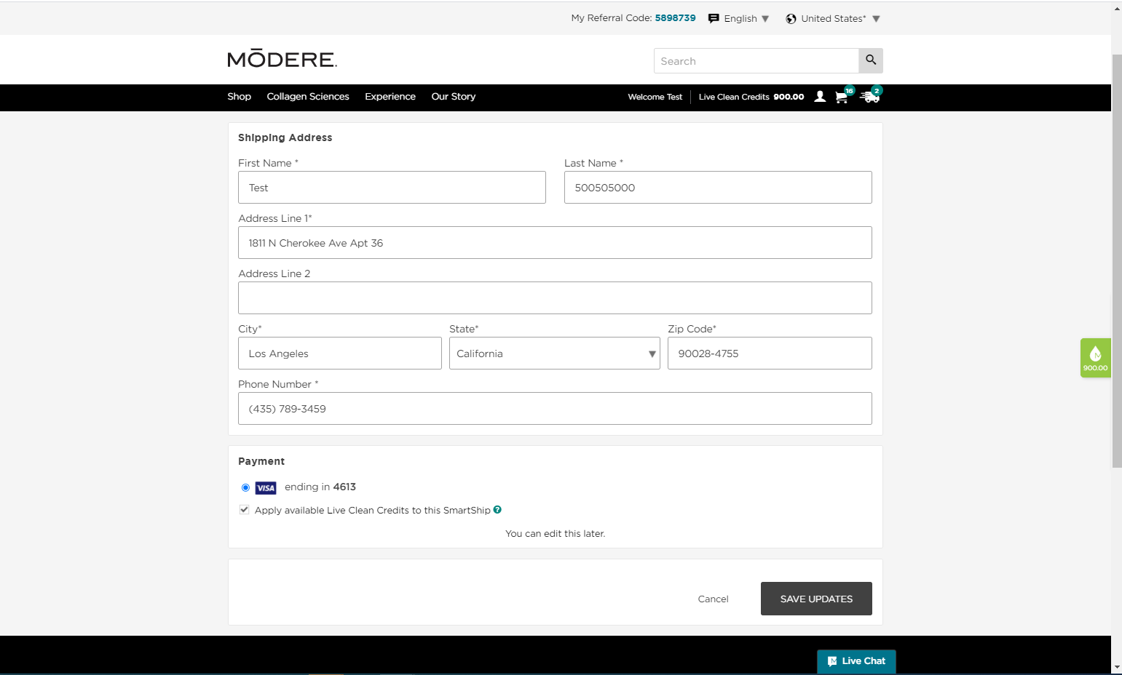
Once the changes are made click the Save Updates button.
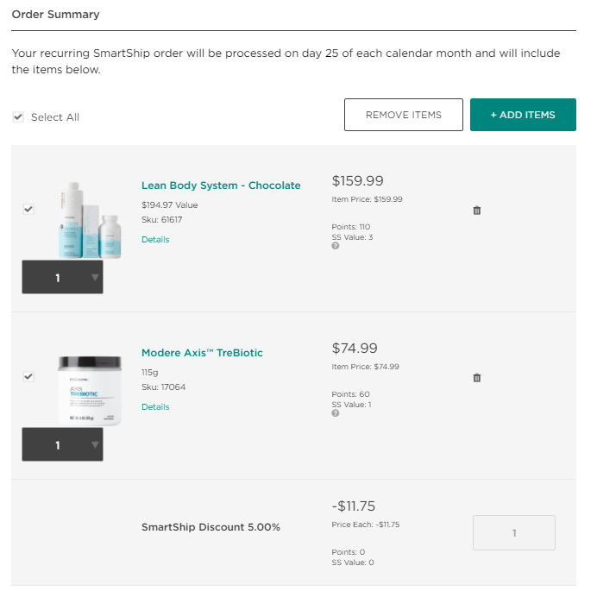
The order summary displays the current SmartShip contents. Add more items to the SmartShip by clicking the Add Items button.
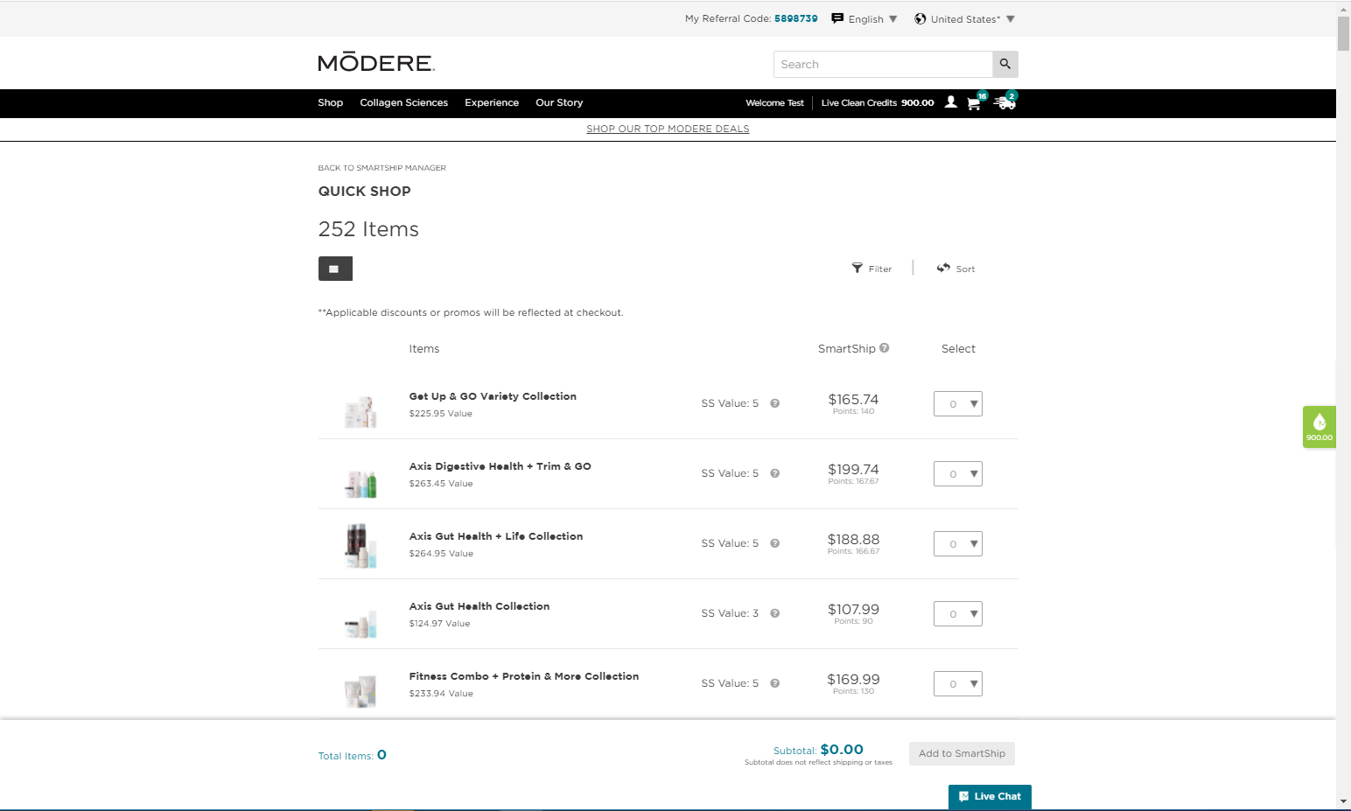
The Quick Shop window appears. Items are added by changing the displayed quantity from 0 to the number desired.
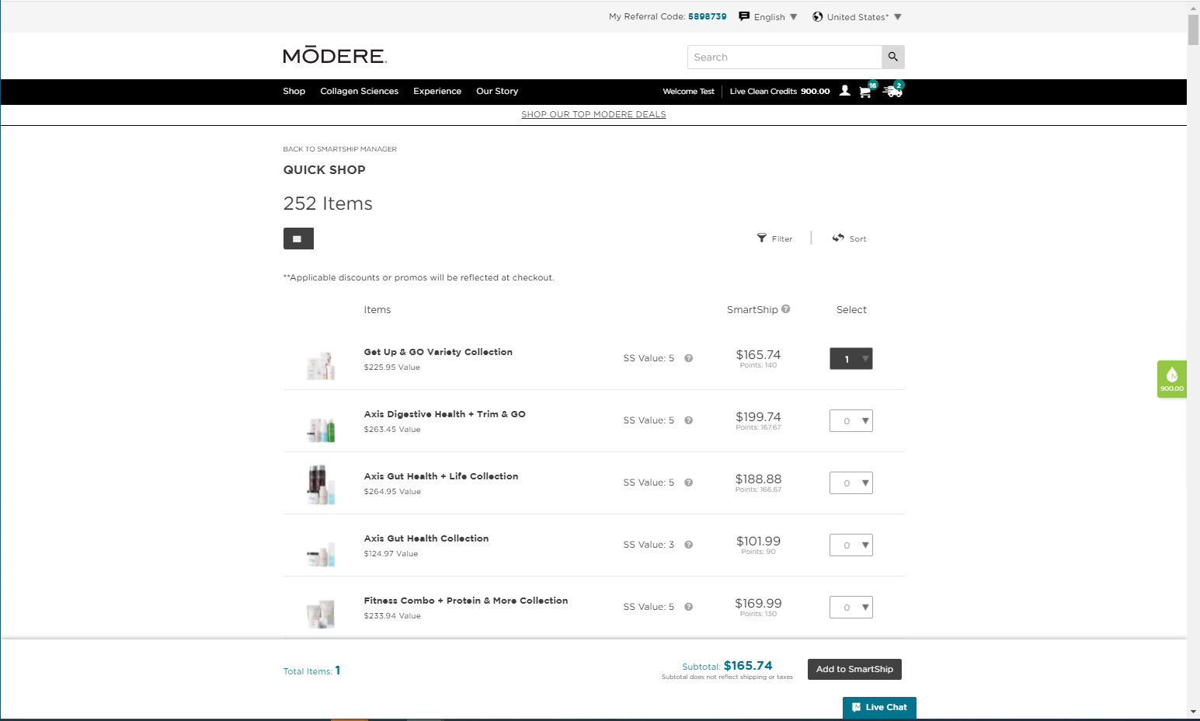
Click the Add to SmartShip button to add the item. Click the Back to SmartShip Manager link to return to the SmartShip Manager.
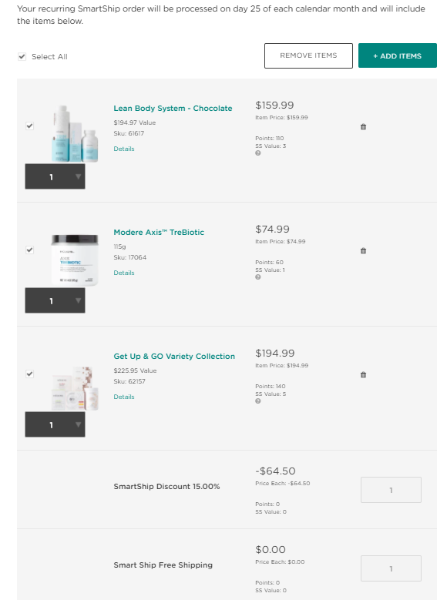
The item is now added to the list of items. There are two ways to delete an item from the list. Individually, click on the trash can icon.
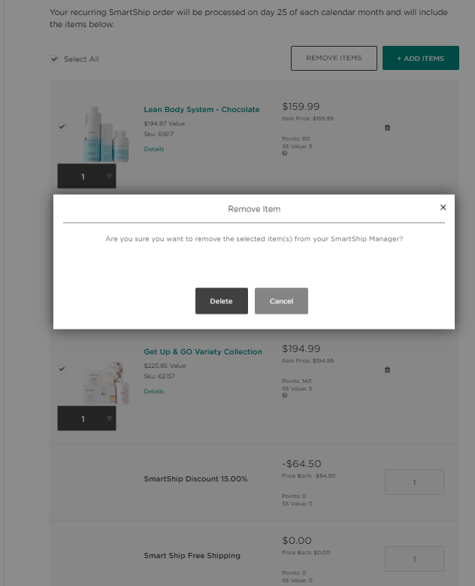
Click the Delete button to confirm the delete.
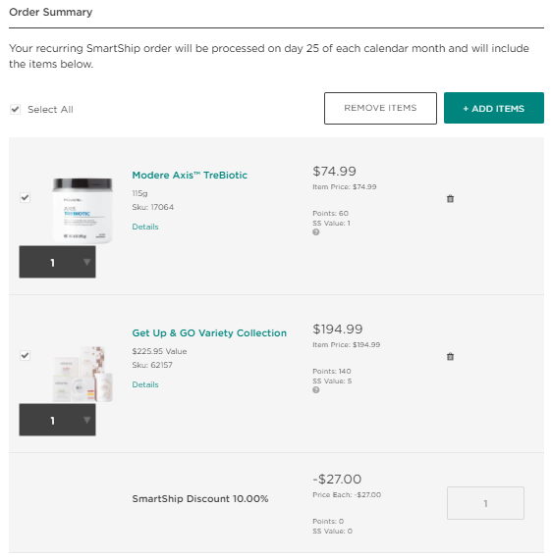
With the Select all checked, the individual items have all been checked. Clicking the Remove Items button removes all the checked items. This can also be used to delete individual items if the Select All is unchecked and the items to remain are unchecked.
Delete SmartShip
By removing all items from the SmartShip the system has nothing to process on the SmartShip run date. You may get a notification email that their SmartShip has processed but there will be no charges on your credit card, and nothing will ship. A template in this state is subsequently deleted by an automated process.
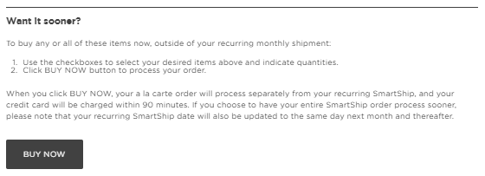
If you want the template processed into an order immediately, click the Buy Now button. The order will process within 90 minutes.

