How To - Submit a Website Ticket

Submit trouble tickets to report problems with our website or applications through Contact Support: CONTACT SUPPORT – Shifting Retail.
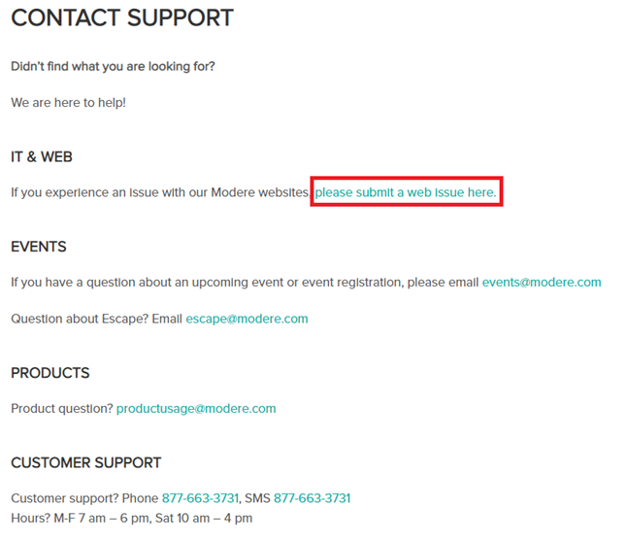
Once on the page select the link in the IT & WEB section: https://app.smartsheet.com/b/form/2e8f7d78e5314014b7a8014f61fe2891
This page displays the information our IT department needs to investigate an issue.
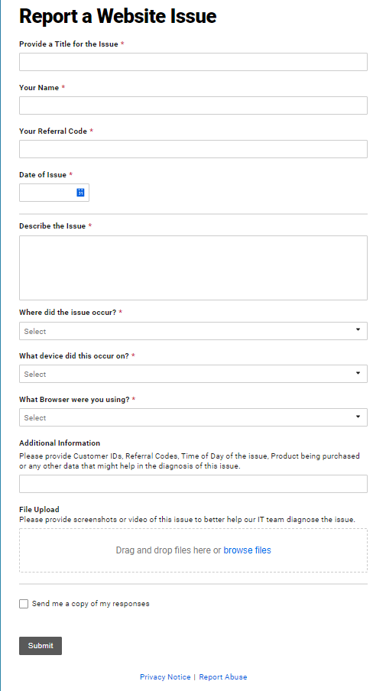
Complete the information in the form then click the Submit button.

