Modere Web Page- Create Account

To place orders for Modere products you need to create an account. Let’s walk through that process.
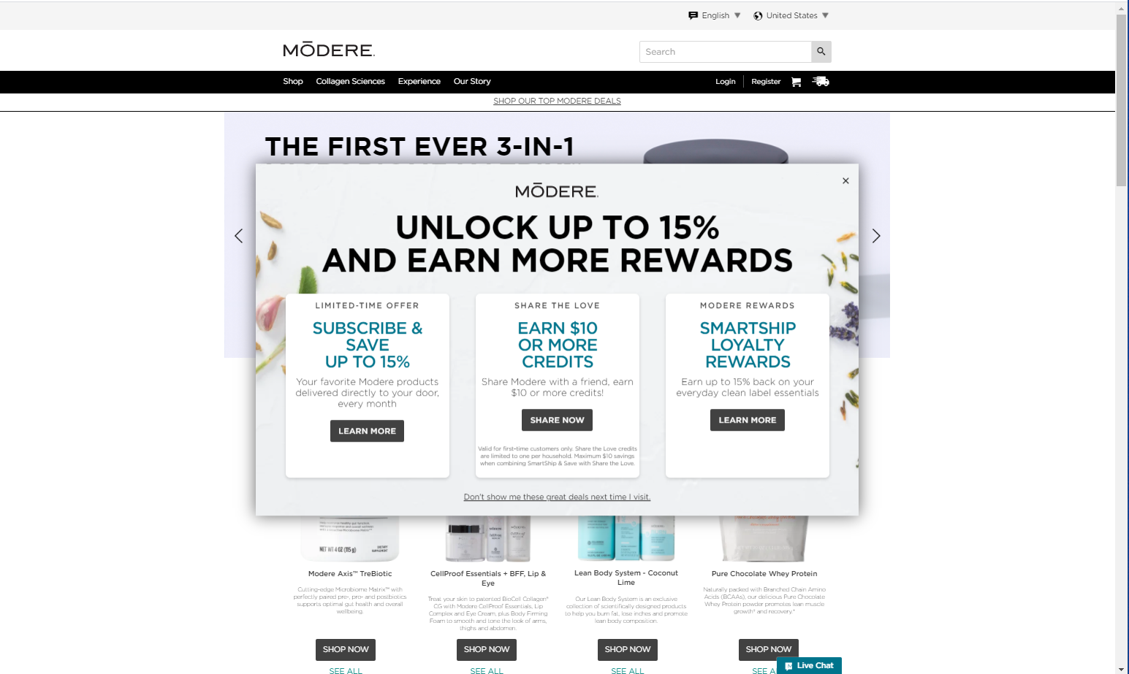
Starts your Modere experience by clicking the Register link in the menu bar.
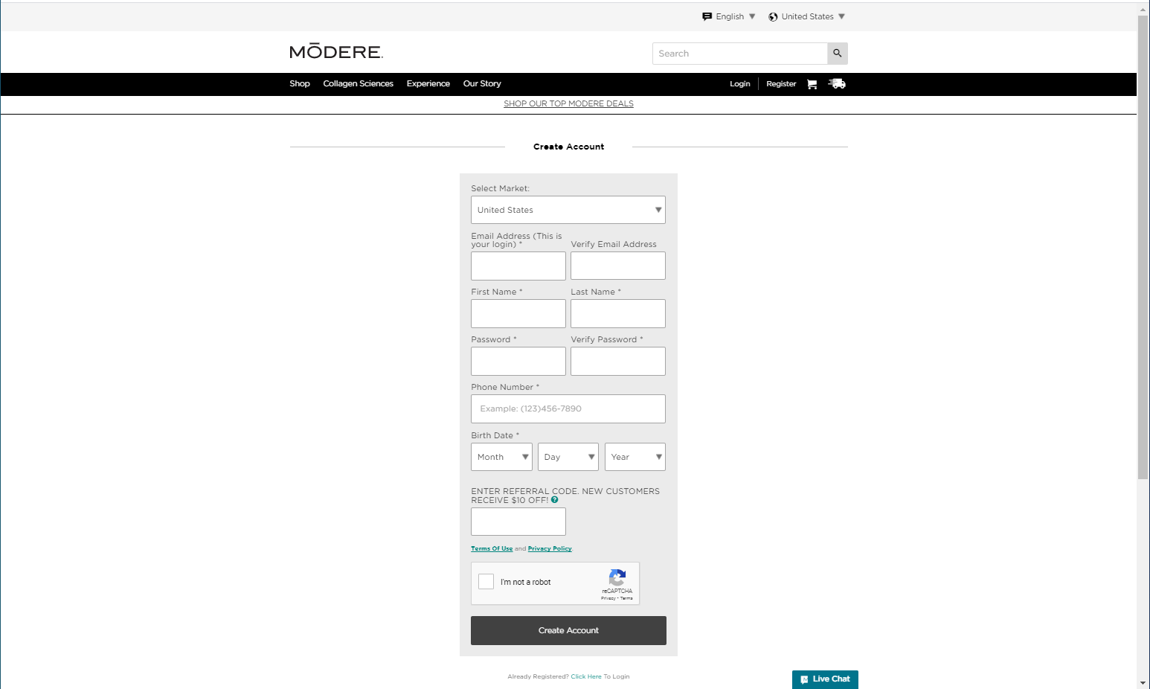
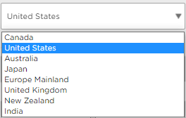
Begin by selecting the correct market. Since the example is a U.S. Customer the United States is the desired market. If you are a Canadian customer, you should be on the Modere.ca page. The steps are the same, although the data will be different.
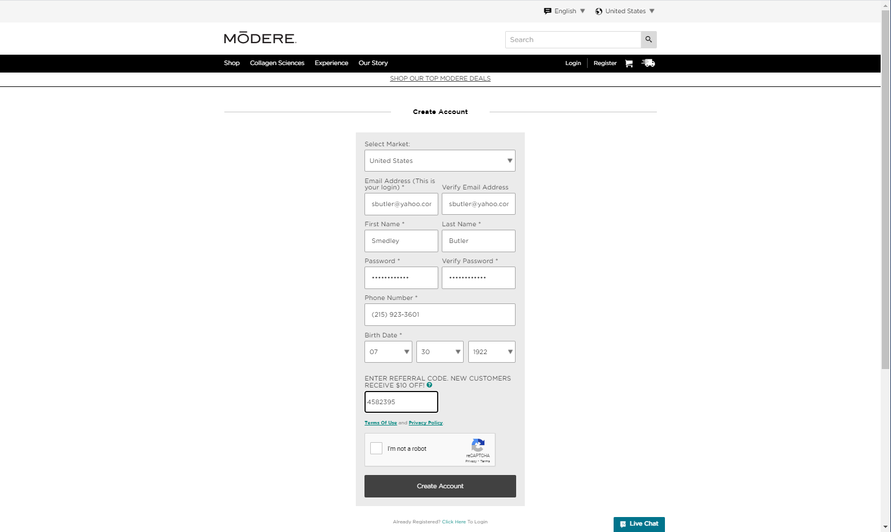
Enter your email, first and last name, phone number and birth date. Then enter the referral code of the person who referred you to Modere.
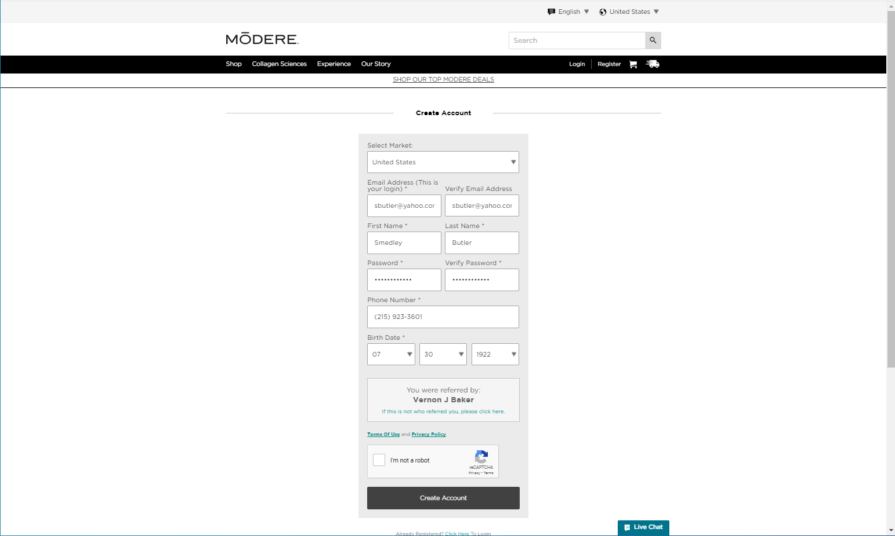
The web page verifies the referral code and displays the name of the person associated with the referral code. Verify the name returned is the person who referred you. If it is not, click the link to clear the field, then enter the correct code. Review the terms of use and privacy policy documents. Then click the Captcha box.
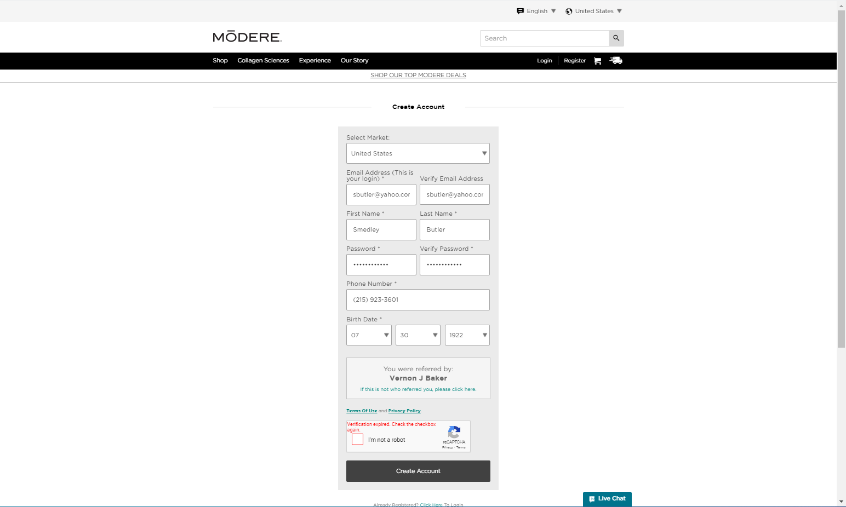

Clicking this box starts a timer. Waiting too long will allow the verification to expire.
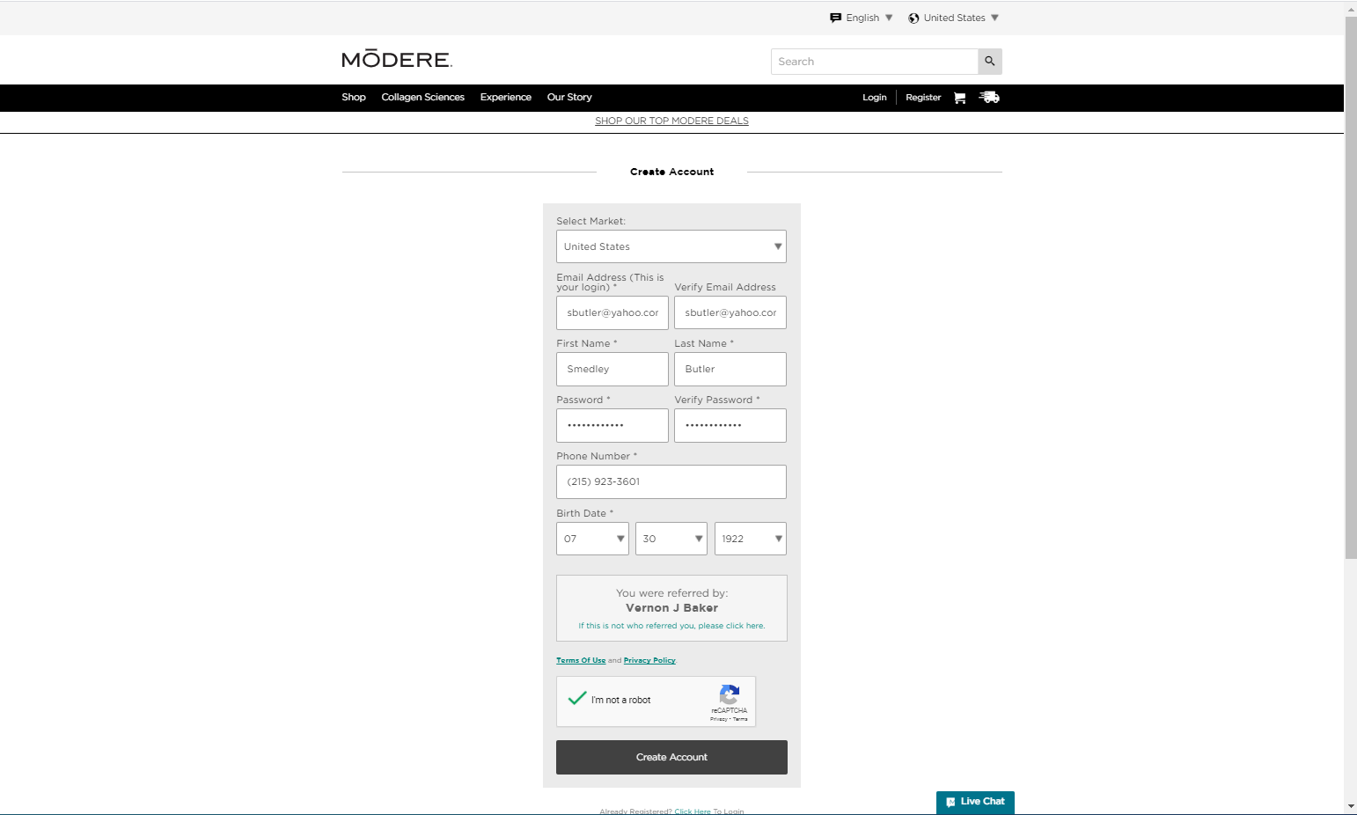
If this happens, check the box again, then click the Create Account button.

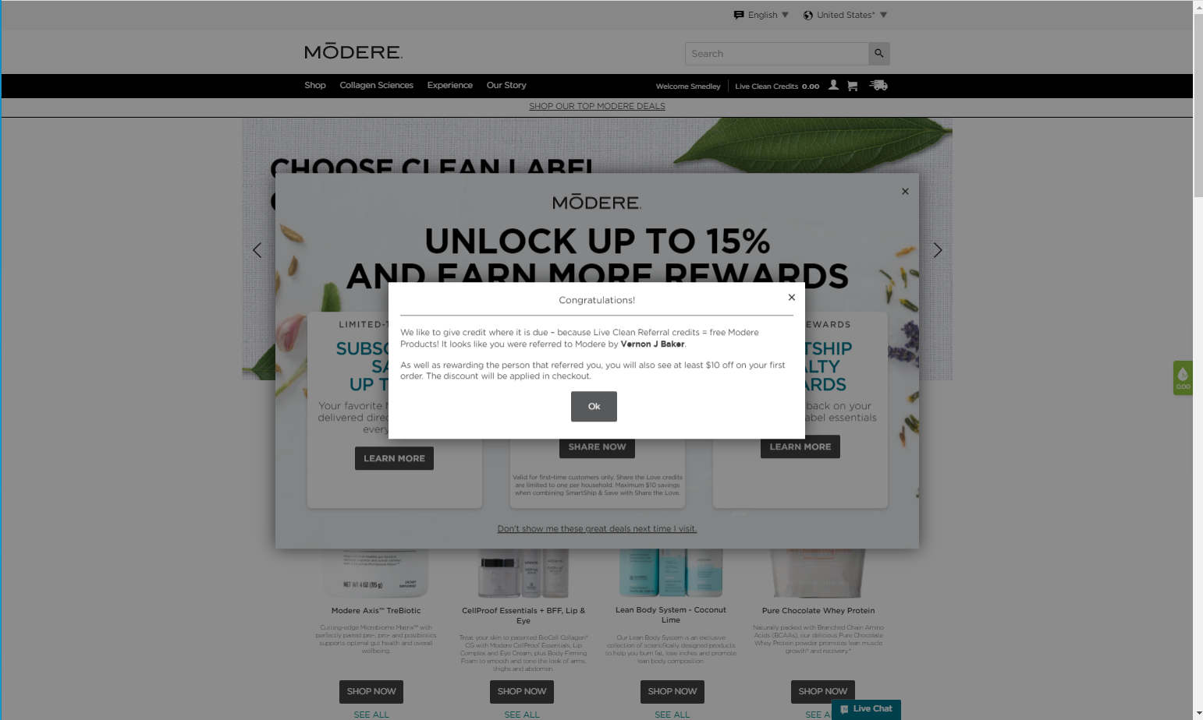
You will see a message indicating that your referring person and you will receive [Share the Love] rewards.
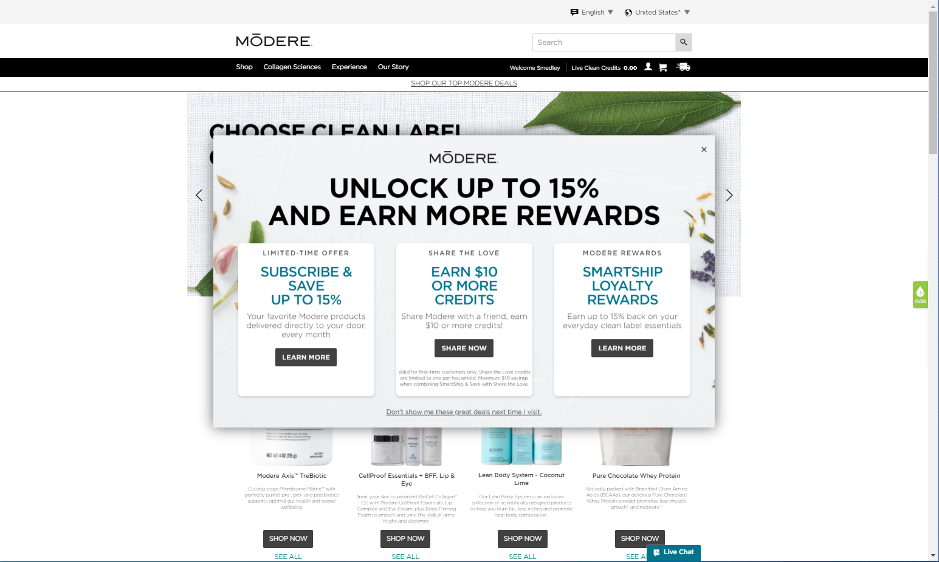
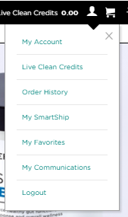
After dismissing the message, you will be logged in but not quite ready for your first order. You need to finish entering your account data. Click the head icon to open the menu, then select My Account.
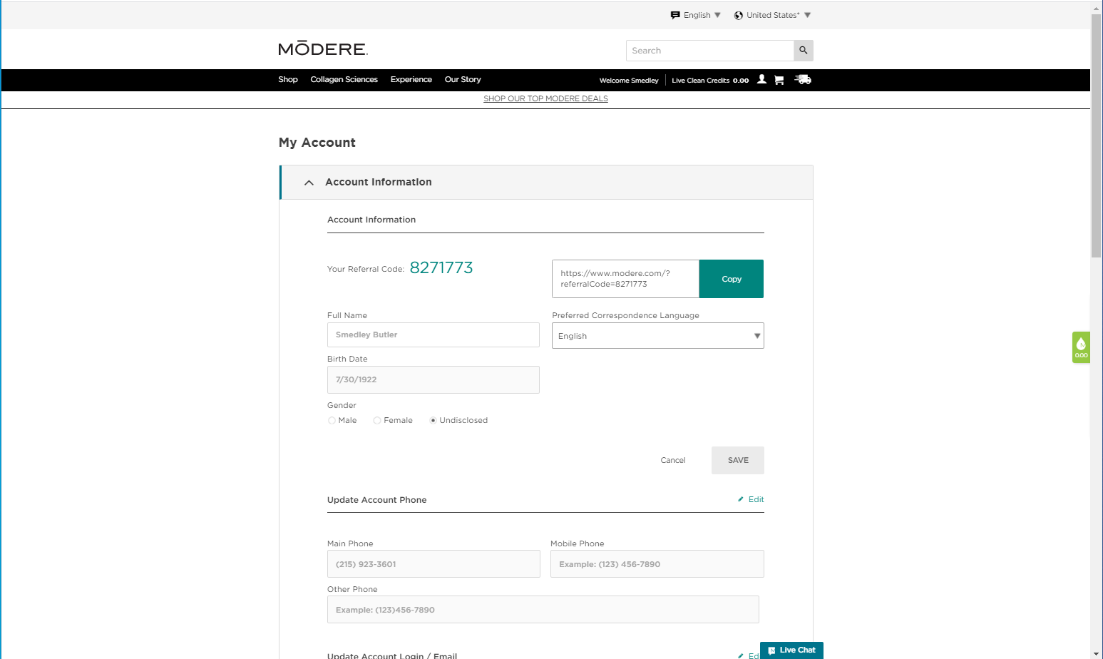
The My Account page shows your referral code and a link that can be shared. This is a male so select a gender of male, then save the changes in the section.
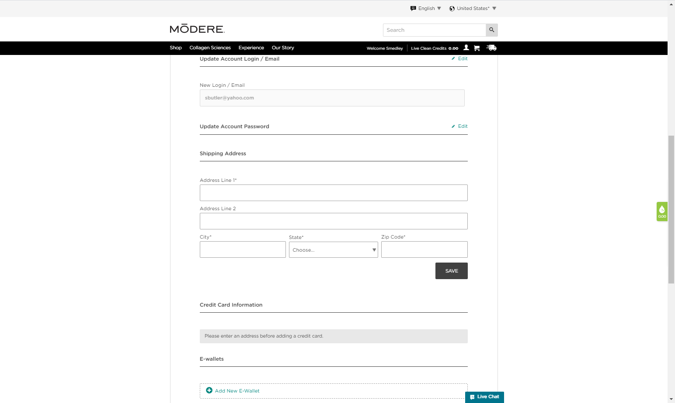
Scroll down to the Shipping Address area and enter a shipping address.
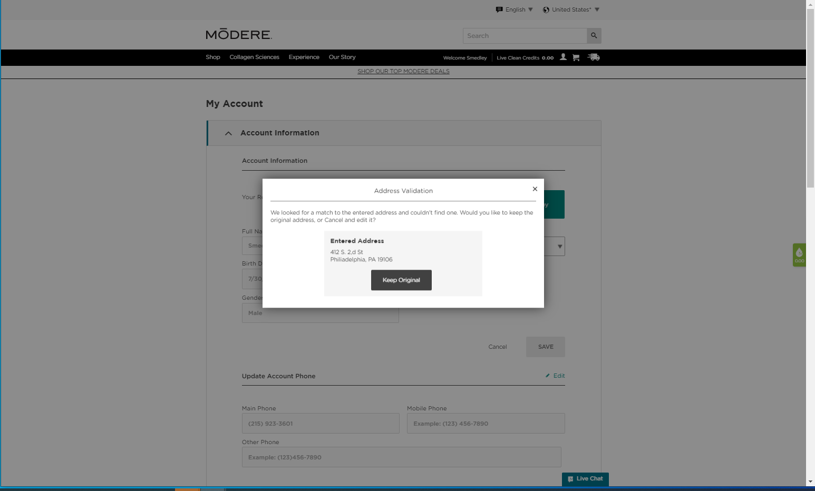
After clicking Save the system validates the entered address and if there is an error returns a message indicating that the address could not be found. Reviewing the address reveals a typographical error.
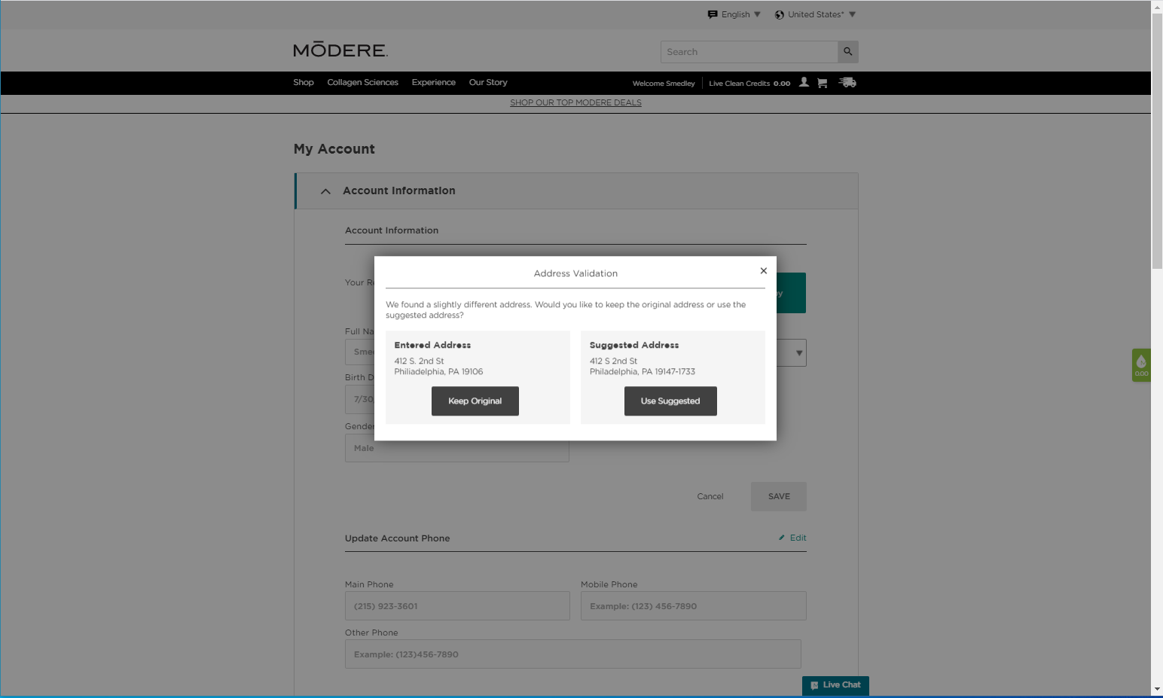
After correcting the error, the system completes the check again and suggests an address with a Zip + 4 correction. Click the Use Suggested button to accept the change.
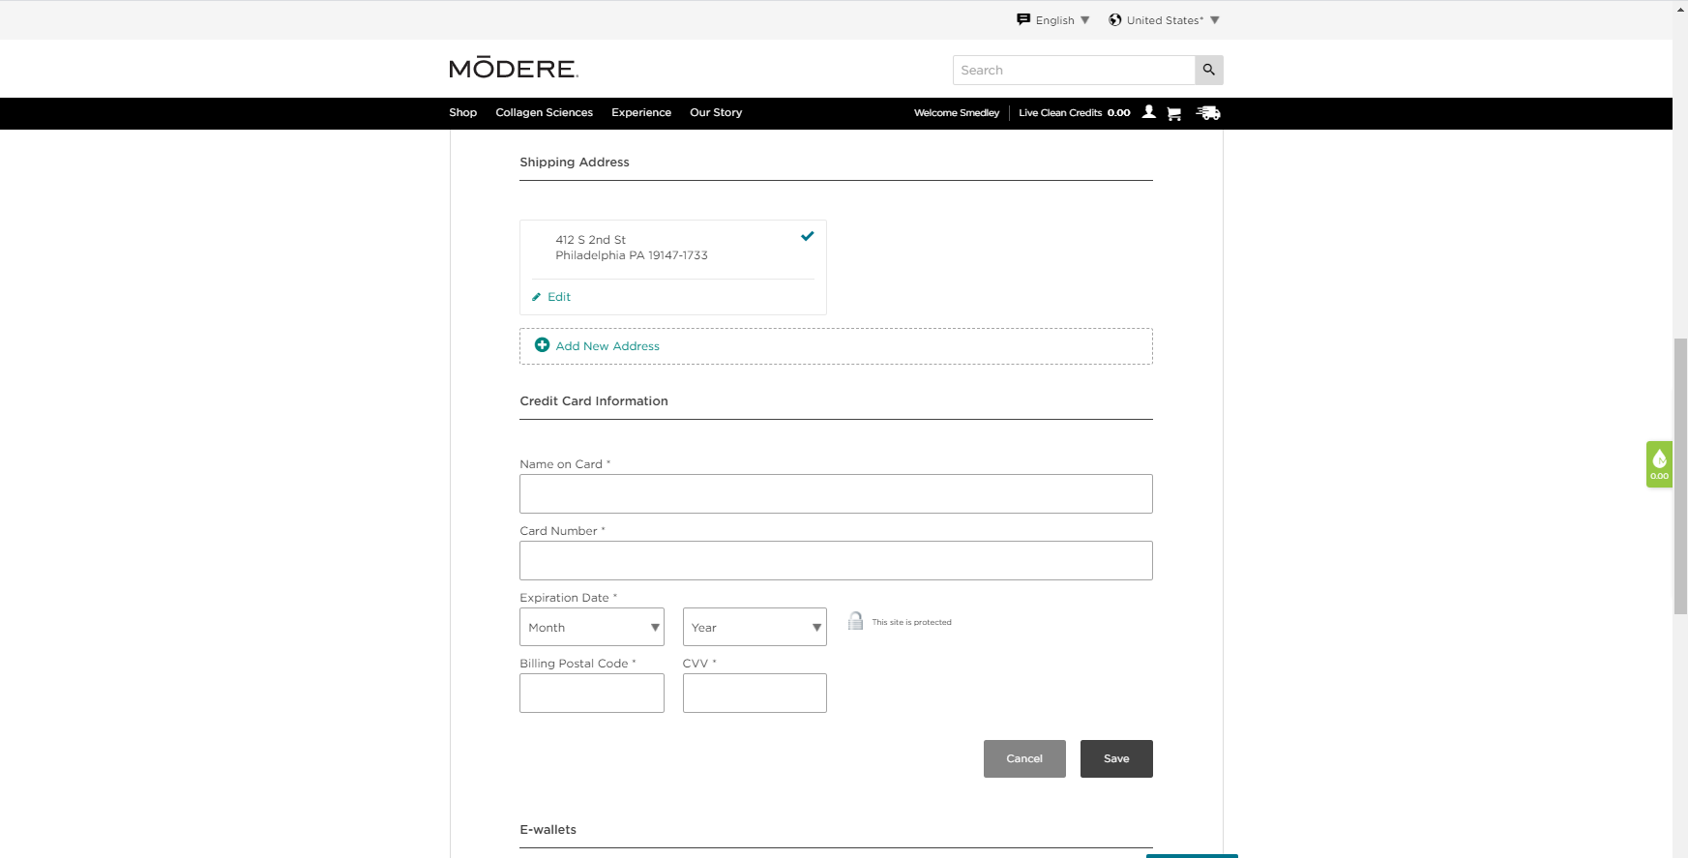
The last item that needs to completed is the payment information. Enter the data then click the Save button.
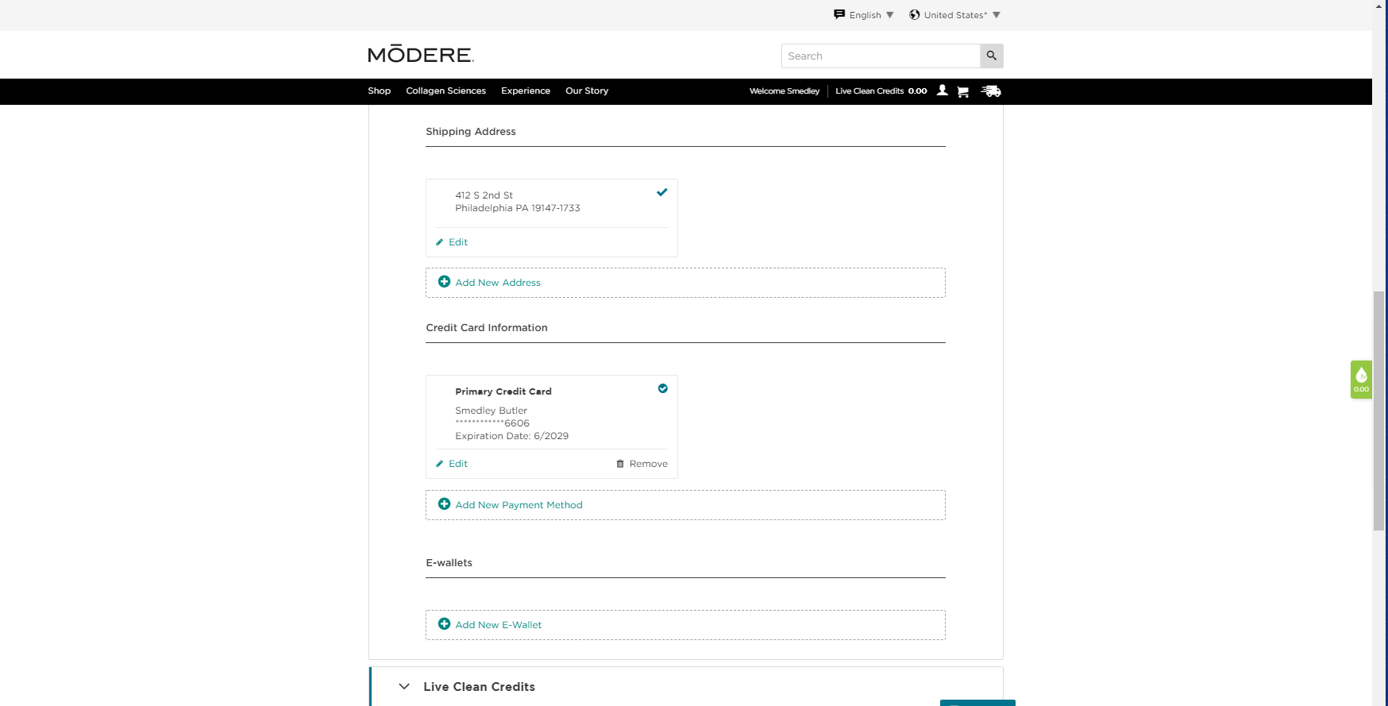
You can add a second card by clicking the Add New Payment Method link.
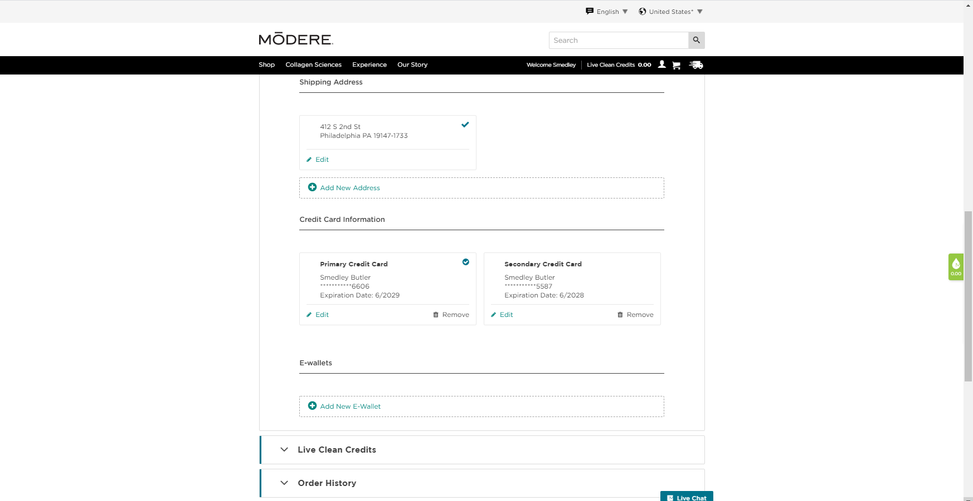
When the second credit card has been entered, the Add New Payment Method is no longer available.
You can add an E-wallet account by clicking on the Add New E-Wallet link.
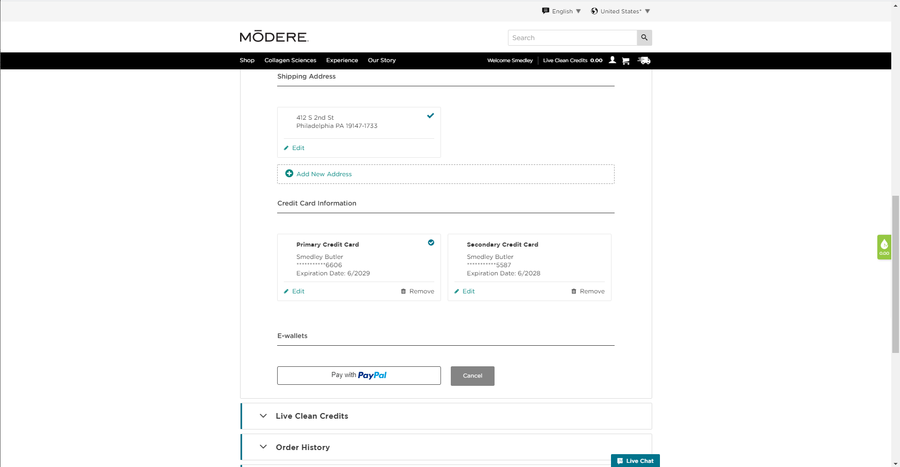
Clicks on the Pay with PayPal button.
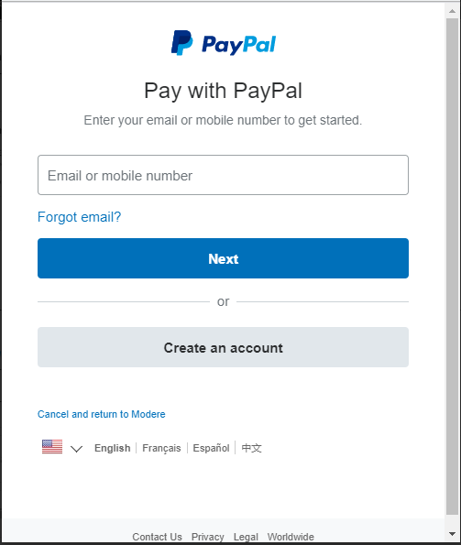
The PayPal login is presented. Once the login credentials are verified, PayPal presents the PayPal payment methods available.
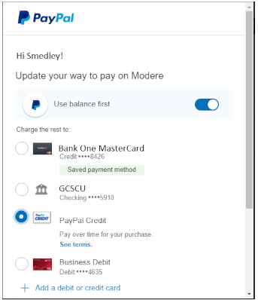
Note that PayPal Credit is an option.
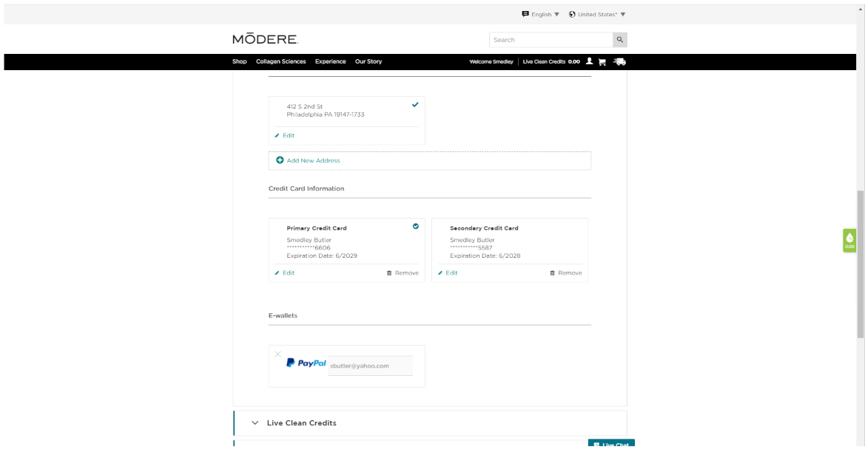
When you have entered an E-wallet account the Add a new E-Wallet link is no longer available.
The account is now complete and ready for the customer to place orders.

