Logging In

Modere Web Page
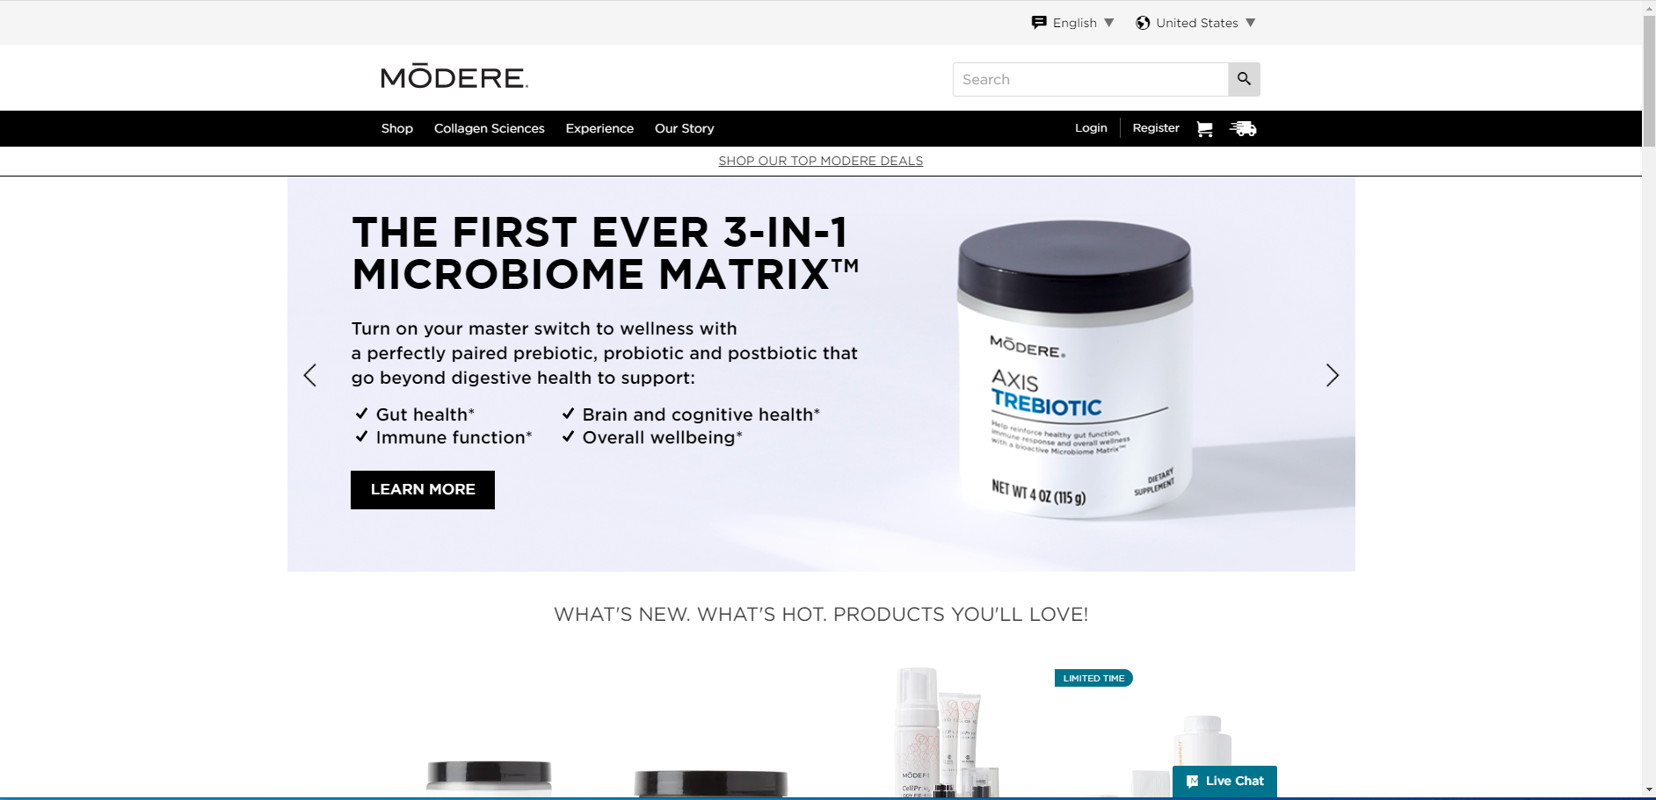
From a browser that has opened the Modere.com web page, click on the Login link.
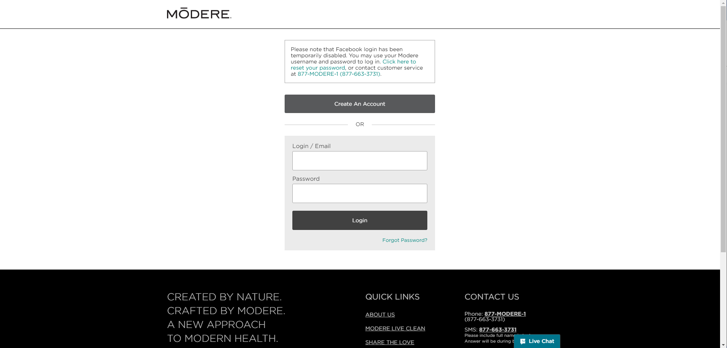
Enter your email address.
Enter your Password.
Click on the Login button.

Modere App
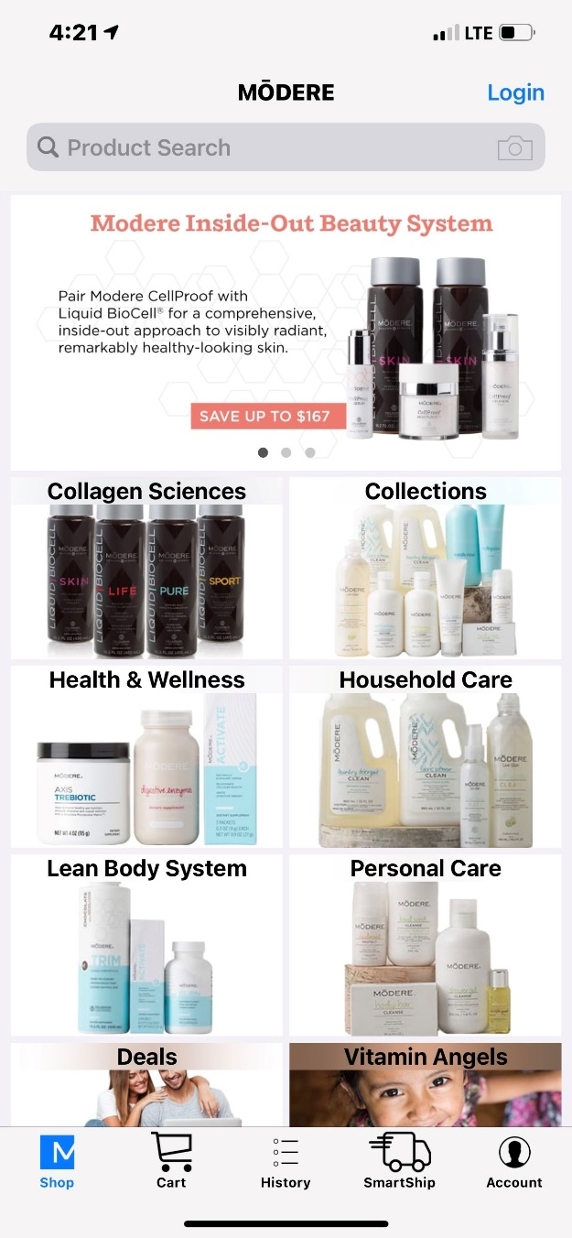
With the Modere App open, tap the Login link.
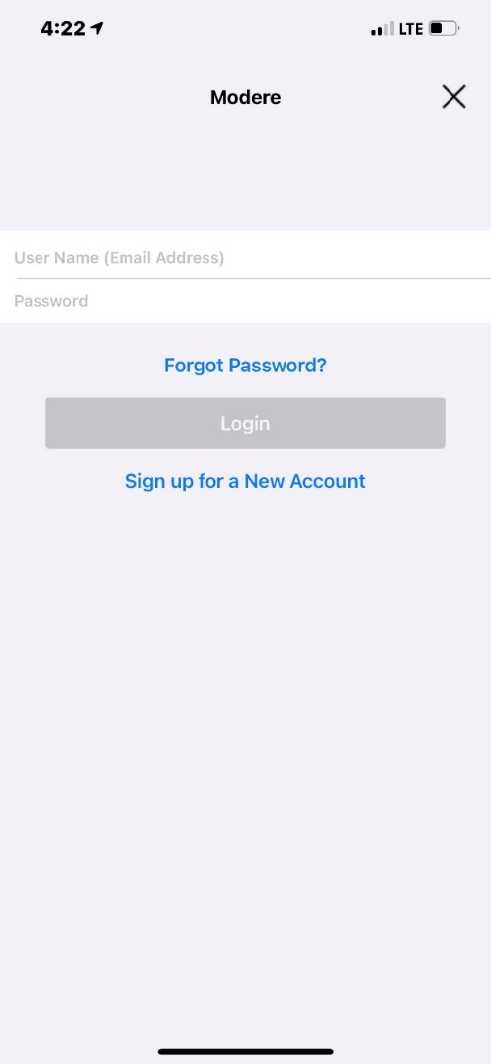
Enter your email address.
Enter your Password.
Click on the Login button. (The button becomes active when the email and password fields are populated)

Modere Life
The Modere Life App is only available to Social Marketers.
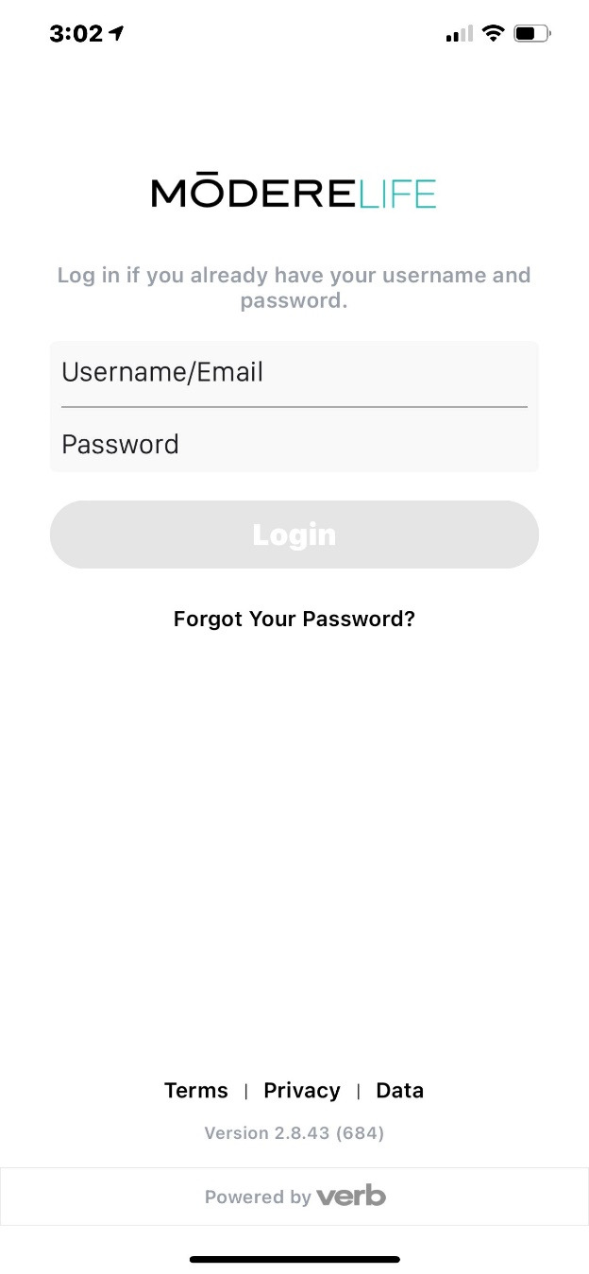
Enter your email address.
Enter your Password.
Click on the Login button. (The button becomes active when the email and password fields are populated)

