# How to – Reset My Password

Having trouble logging in?

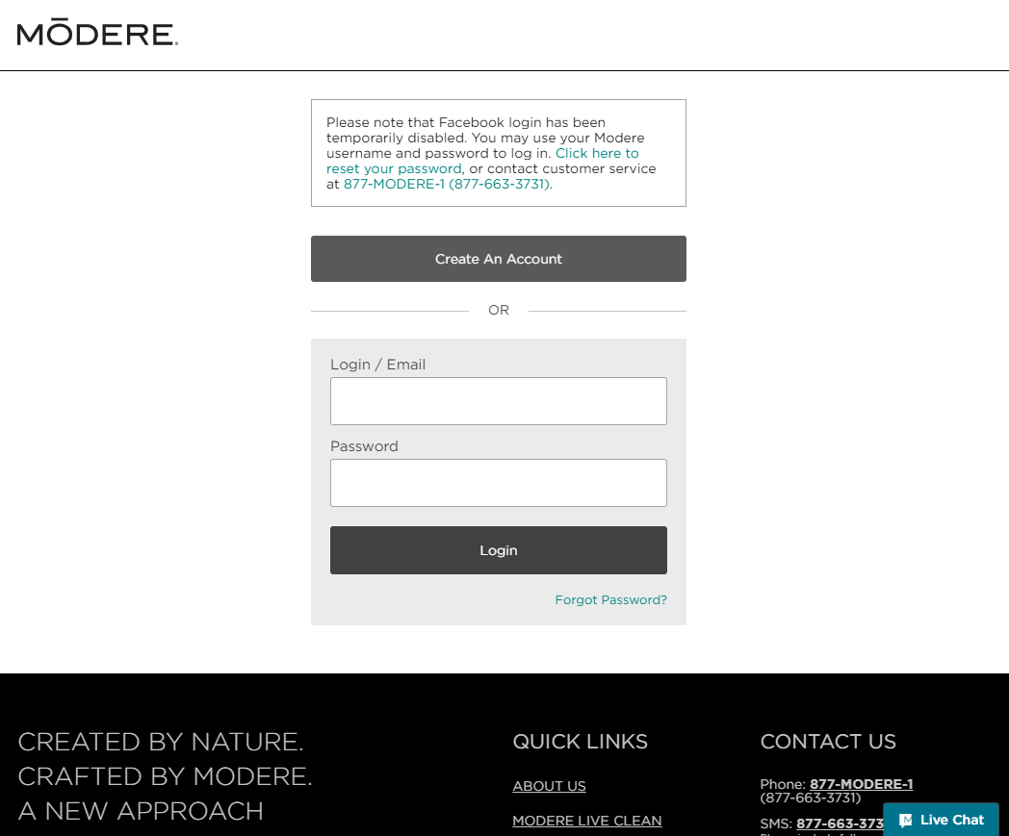

From the login page, click the Forgot Password? link.

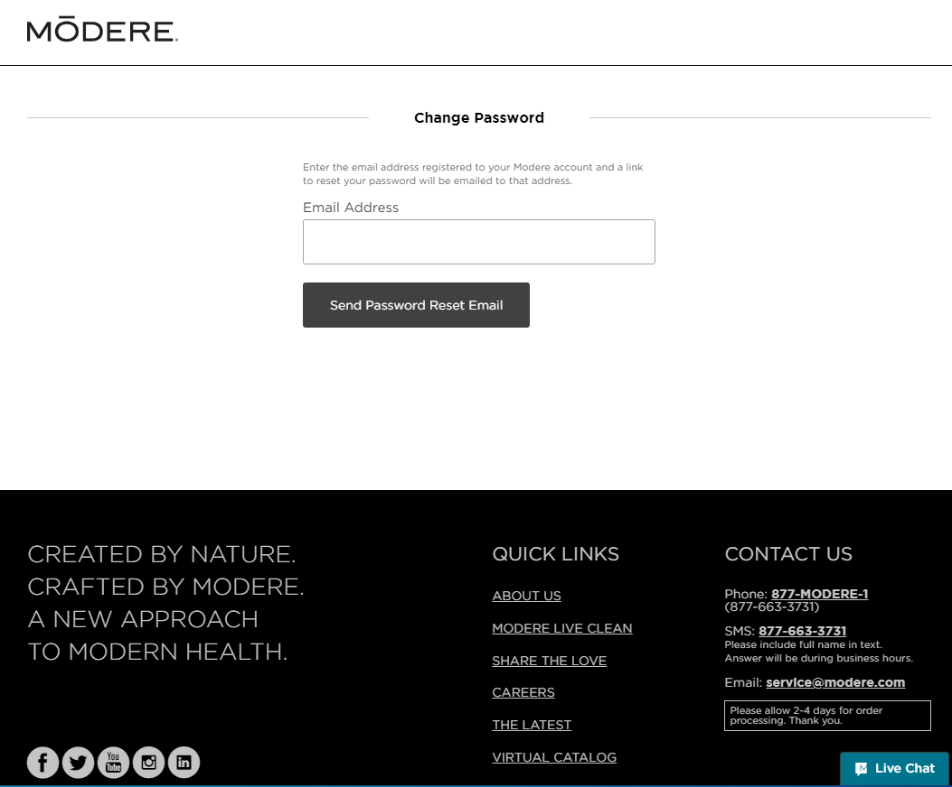

Enter your email address, then click the Send Password Reset Email button.

You will receive an email from the system with a password reset link.

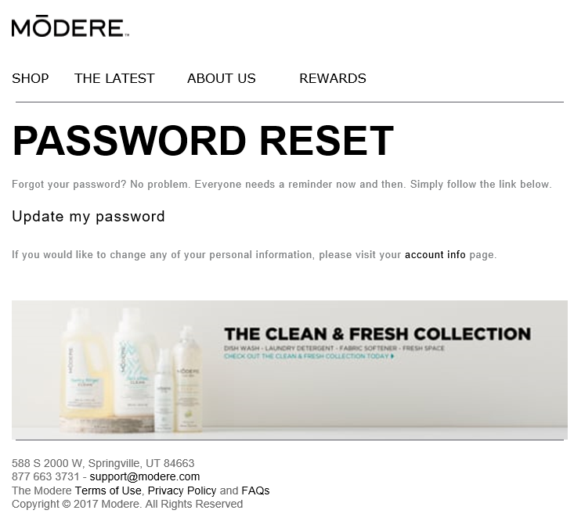

Click the Update my Password link.

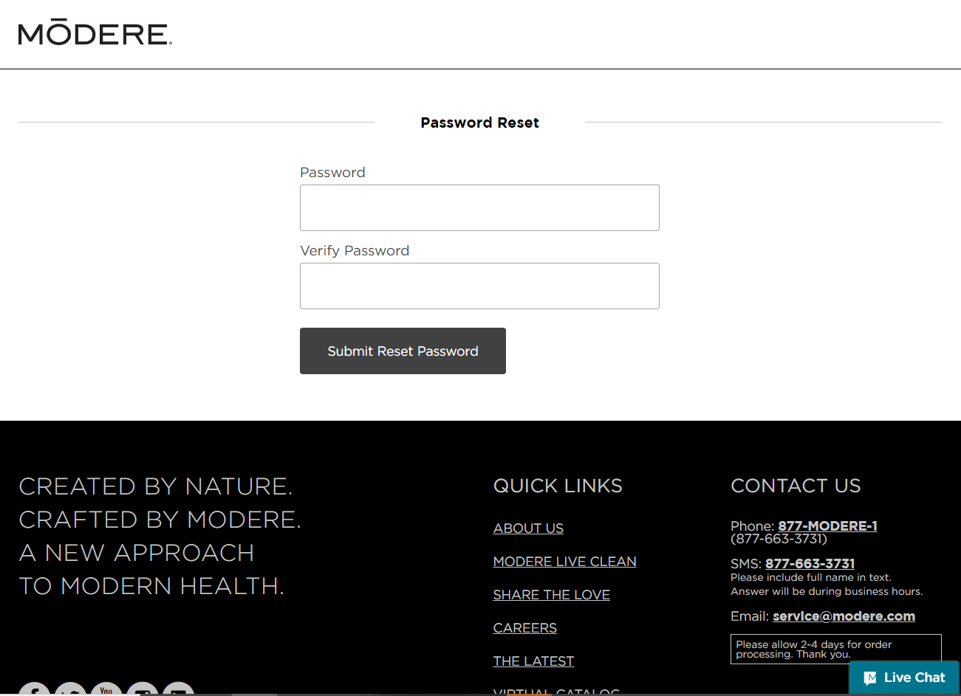

Enter a new password.

Verify the new password.

Click the Submit Reset Password.